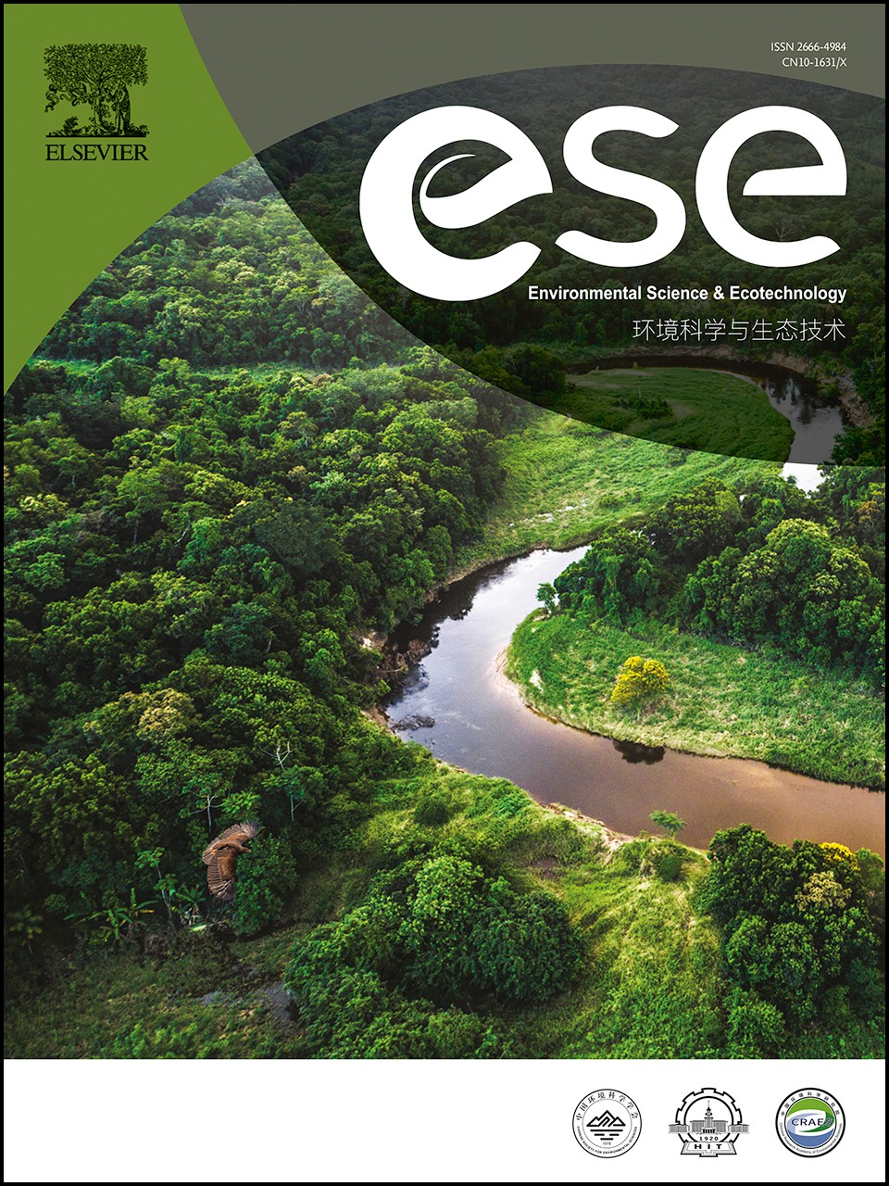Journal Pre-proof

Peracetic acid (PAA)-based pretreatment effectively improves medium-chain fatty acids (MCFAs) production from sewage sludge

Yufen Wang, Haixiao Guo, Xuecheng Li, Xueming Chen, Lai Peng, Tingting Zhu, Peizhe Sun, Yiwen Liu

PII: S2666-4984(23)00120-5

DOI: <https://doi.org/10.1016/j.ese.2023.100355> Reference: ESE 100355

To appear in: *Environmental Science and Ecotechnology*

Received Date: 23 May 2023

Revised Date: 17 November 2023

Accepted Date: 23 November 2023

Please cite this article as: Y. Wang, H. Guo, X. Li, X. Chen, L. Peng, T. Zhu, P. Sun, Y. Liu, Peracetic acid (PAA)-based pretreatment effectively improves medium-chain fatty acids (MCFAs) production from sewage sludge, *Environmental Science and Ecotechnology* (2024), doi: [https://doi.org/10.1016/](https://doi.org/10.1016/j.ese.2023.100355) [j.ese.2023.100355](https://doi.org/10.1016/j.ese.2023.100355).

This is a PDF file of an article that has undergone enhancements after acceptance, such as the addition of a cover page and metadata, and formatting for readability, but it is not yet the definitive version of record. This version will undergo additional copyediting, typesetting and review before it is published

in its final form, but we are providing this version to give early visibility of the article. Please note that, during the production process, errors may be discovered which could affect the content, and all legal disclaimers that apply to the journal pertain.

© 2023 Published by Elsevier B.V. on behalf of Chinese Society for Environmental Sciences, Harbin Institute of Technology, Chinese Research Academy of Environmental Sciences.

**PAA**

**Intact WAS flocs**

**EPS disruption and transformation**

**Formation of amino acids, glucose, etc.**

**Singlet oxygen**

**Inorganic radicals**

**Ethanol/CO2**

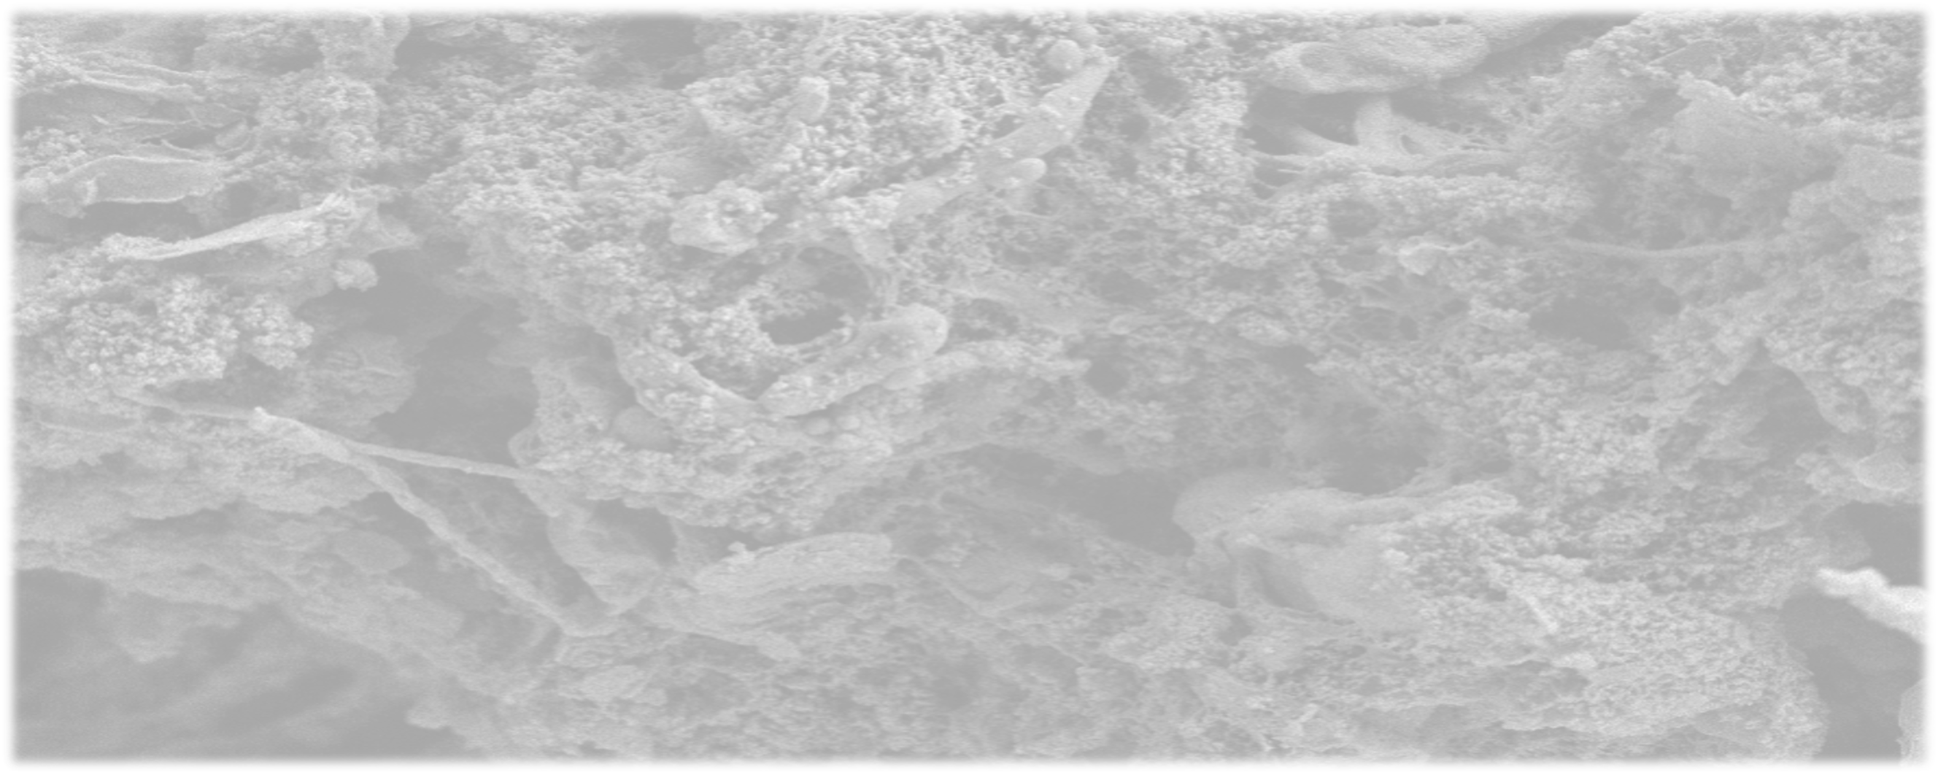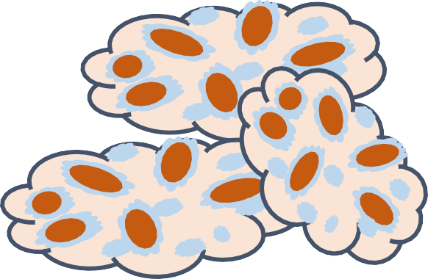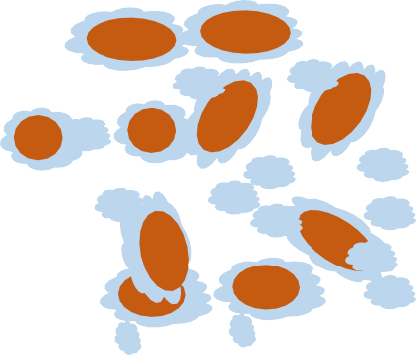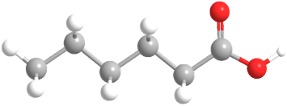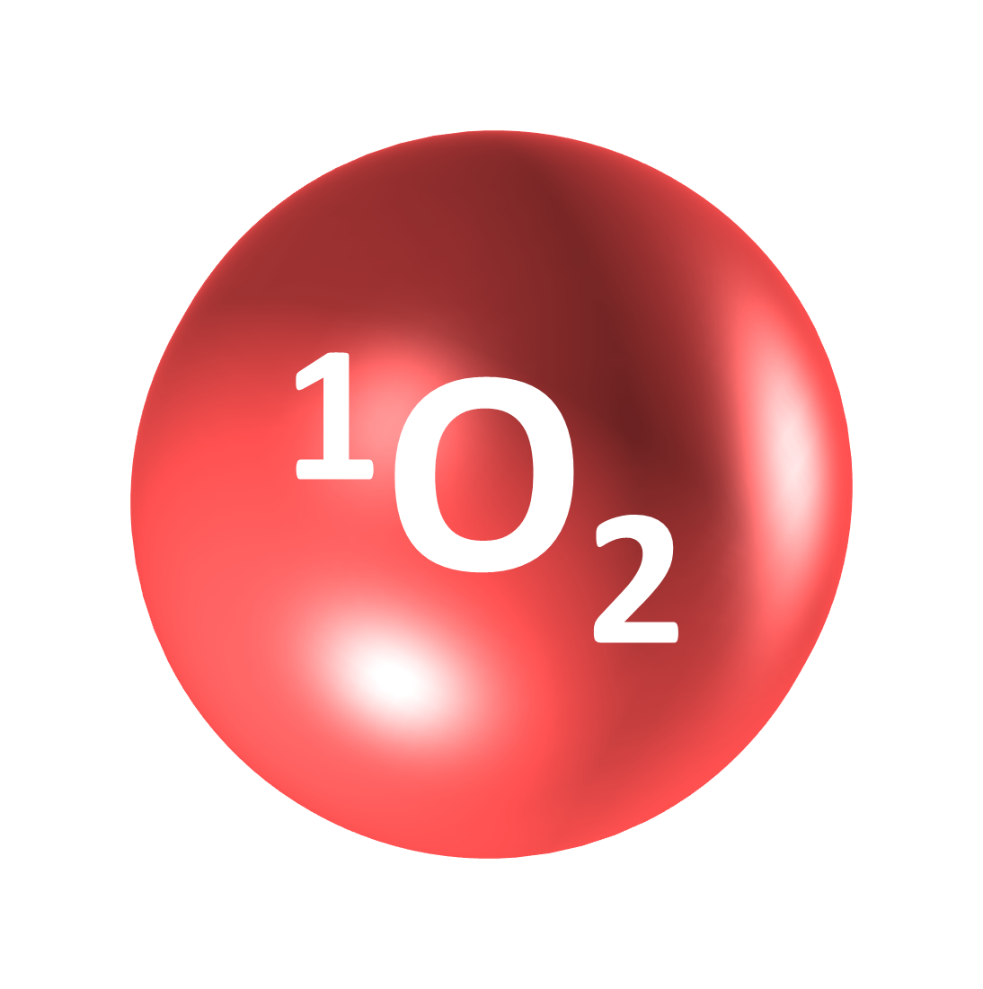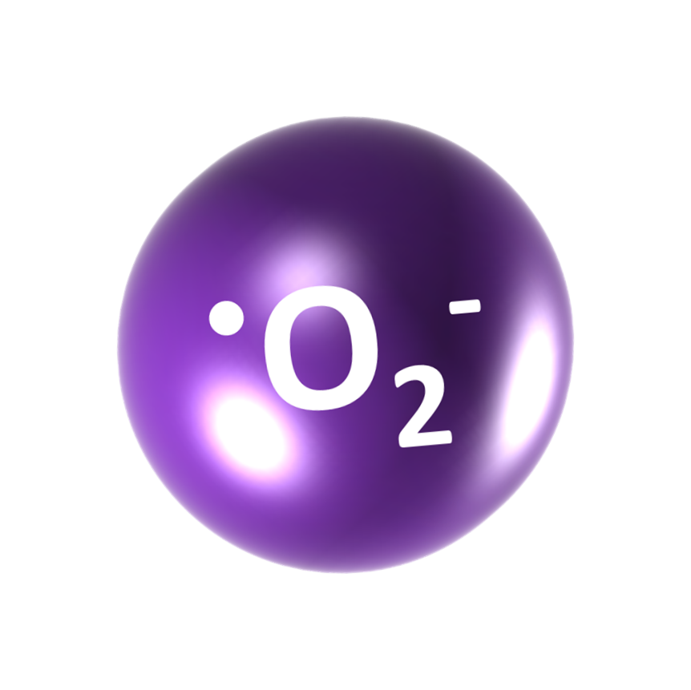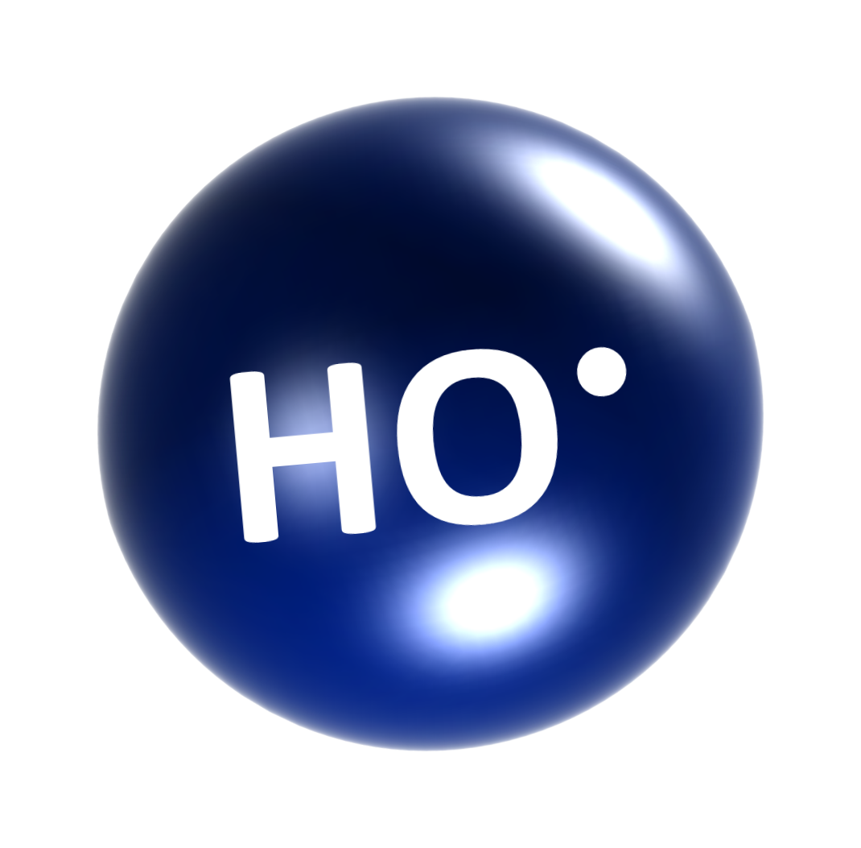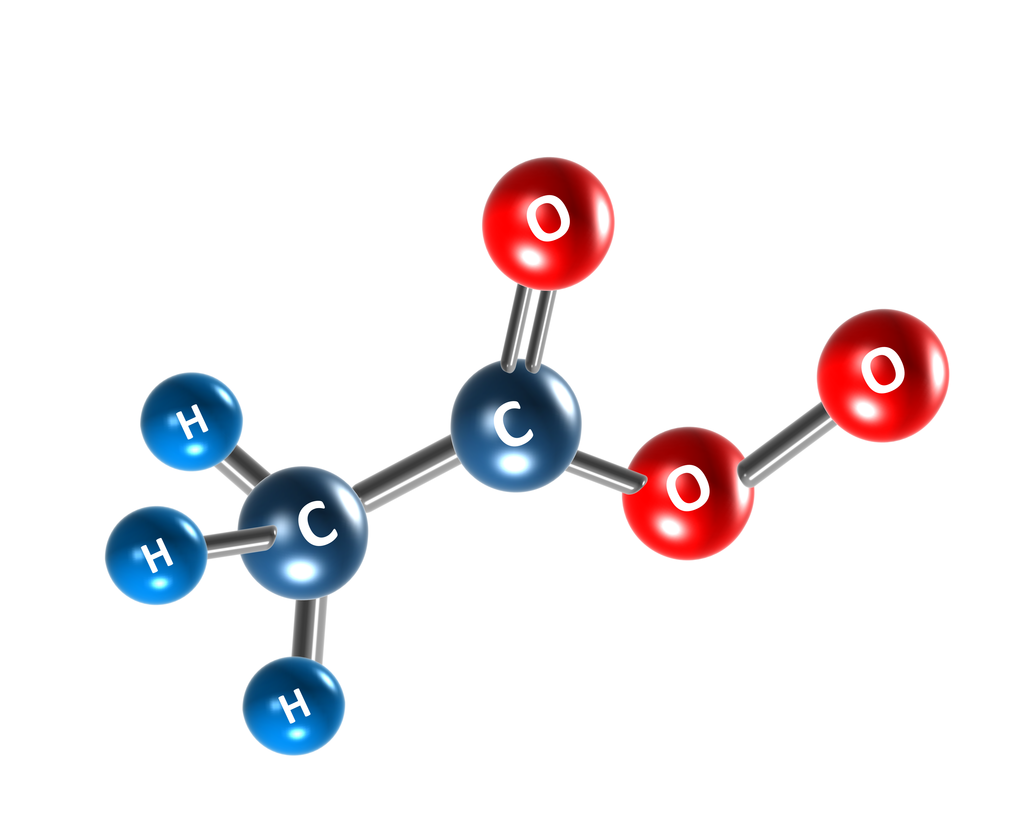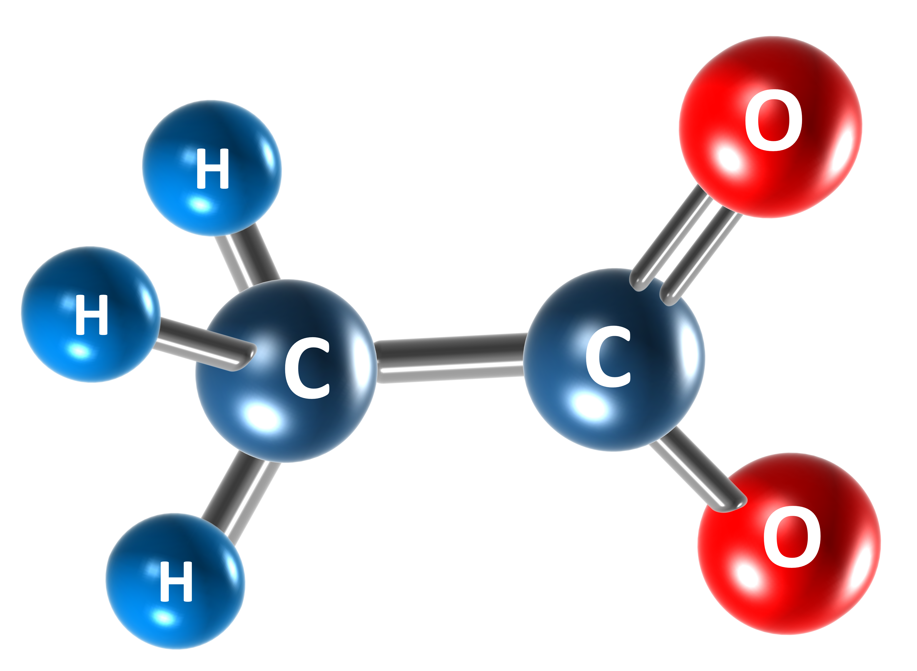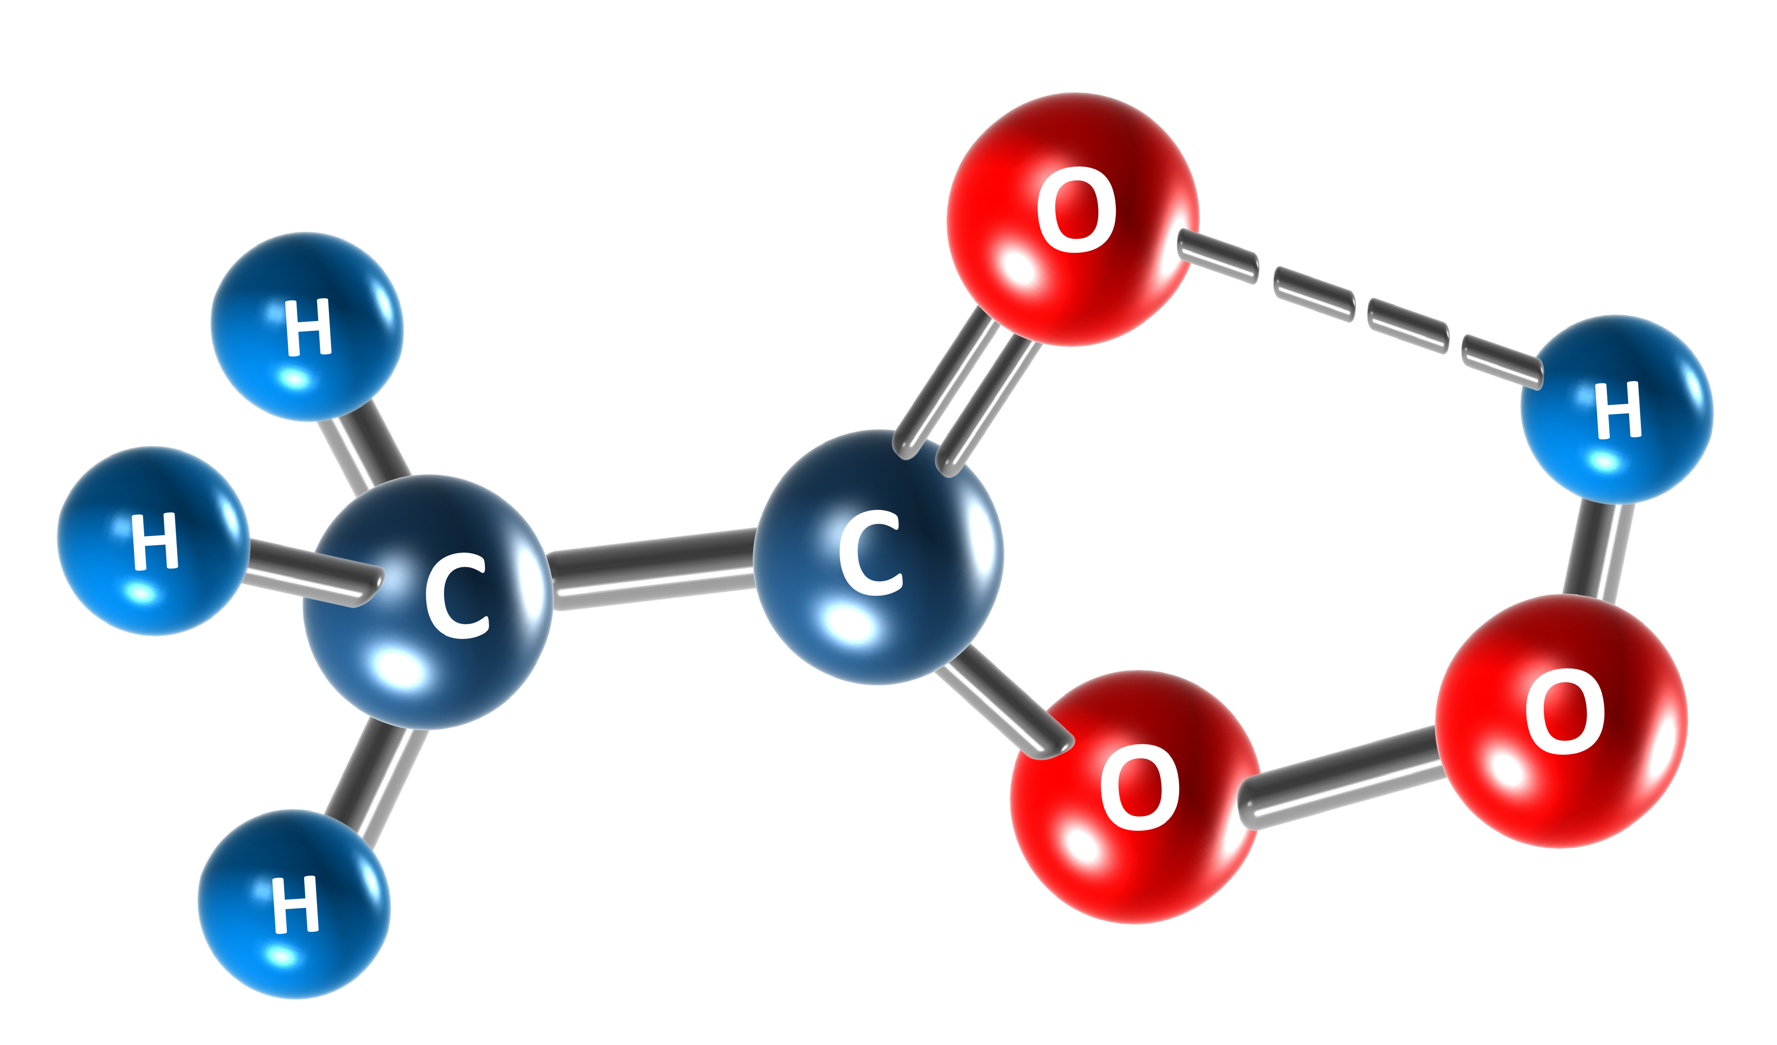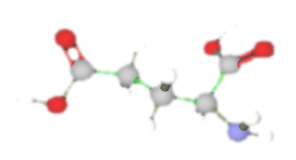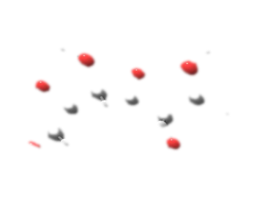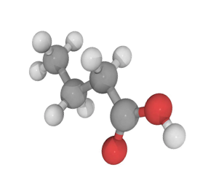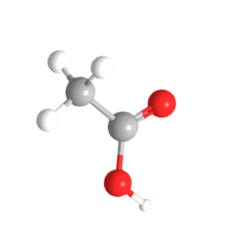

**Organic radicals**

**MCFA**

**FAB pathway RBO pathway**

**Acetate, butyrate, etc.**

**Peracetic acid (PAA)-based pretreatment effectively improves medium-chain fatty acids (MCFAs) production from sewage sludge**

Yufen Wang a, Haixiao Guo a, Xuecheng Li a, Xueming Chen b, Lai Peng c, d, Tingting Zhu a, Peizhe Sun a, Yiwen Liu a,*

a School of Environmental Science and Engineering, Tianjin University, Tianjin 300072,

China

b Fujian Provincial Engineering Research Center of Rural Waste Recycling Technology, College of Environment and Safety Engineering, Fuzhou University, Fujian 350116,

China

c Hubei Key Laboratory of Mineral Resources Processing and Environment, Wuhan University of Technology, Luoshi Road 122, Wuhan, Hubei 430070, China

d School of Resources and Environmental Engineering, Wuhan University of Technology, Luoshi Road 122, Wuhan, Hubei 430070, China

*Corresponding author

E-mail: [yiwen.liu@tju.edu.cn](mailto:yiwen.liu@tju.edu.cn) (Y. Liu)

1. **Abstract:** Peracetic acid (PAA), known for its environmentally friendly properties as a
2. oxidant and bactericide, is gaining prominence in decontamination and disinfection
3. applications. The primary product of PAA oxidation is acetate that can serve as an
4. electron acceptor (EA) for the biosynthesis of medium-chain fatty acids (MCFAs) via
5. chain elongation (CE) reactions. Hence, PAA-based pretreatment is supposed to be
6. beneficial for MCFAs production from anaerobic sludge fermentation, as it could
7. enhance organic matter availability, suppress competing microorganisms and furnish
8. EA by providing acetate. However, such a hypothesis has rarely been proved. Here we
9. reveal that PAA-based pretreatment leads to significant exfoliation of extracellular
10. polymeric substances (EPS) from sludge flocs and disruption of proteinic secondary
11. structures, through inducing highly active free radicals and singlet oxygen. The
12. production of MCFAs increases substantially to 11,265.6 mg COD L−1, while the
13. undesired byproducts, specifically long-chain alcohols (LCAs), decrease to 723.5 mg
14. COD L−1. Microbial activity tests further demonstrate that PAA pretreatment stimulates
15. the CE process, attributed to the up-regulation of functional genes involved in fatty acid
16. biosynthesis pathway. These comprehensive findings provide insights into the
17. effectiveness and mechanisms behind enhanced MCFAs production through PAA-
18. based technology, advancing our understanding of sustainable resource recovery from
19. sewage sludge.

20

1. **Keywords:** Sewage sludge; Medium-chain fatty acids (MCFAs); Extracellular
2. polymeric substances (EPS); Peracetic acid (PAA); Metabolic activity.
3. **1. Introduction**
4. The recycling of sewage sludge, including primary sludge and waste activated
5. sludge (WAS), which are inherent byproducts of biological wastewater treatment, is an
6. important part of achieving carbon neutrality at wastewater treatment plants (WWTPs)
7. [1-3]. As a low-cost and simple technology, anaerobic fermentation can effectively
8. reduce the contamination properties of sludge and convert organic fractions into value-
9. added products [4, 5]. Compared to short-chain fatty acids (SCFAs, i.e., traditional
10. fermentation products), medium-chain fatty acids (MCFAs) carry higher energy
11. densities. They are more hydrophobic and can be easily separated from fermentation
12. liquor [6-8]. MCFAs, denoting straight-chain monocarboxylates containing 6–12
13. carbon atoms, primarily encompass caproate, heptylate, and caprylate when produced
14. through biotechnological means [9]. MCFAs can be employed in diverse industries,
15. such as food additives and antimicrobial agents [6]. They are also precursors to
16. manufacture industrial products, e.g., surfactants, lubricants, plasticizers, etc., or to
17. synthesize jet fuel and diesel [10]. Consequently, MCFAs have a higher economic and
18. practical value.
19. Sewage sludge is a suitable and cheap substrate for MCFAs production. On one
20. hand, most organics in sludge can be biodegraded into acetate-dominated SCFAs. Chain
21. elongation (CE) microorganisms prefer to initiate CE with acetate as the initial electron
22. acceptor (EA) [11]. Meanwhile, sewage sludge is rich in microorganisms and
23. extracellular hydrolytic enzymes, e.g., acid-producing bacteria, CE microorganisms,
24. and protease, benefiting hydrolysis/acidification of substrates and SCFAs upgrading
25. [12]. When electron donor (ED, commonly ethanol) is sufficient, CE microorganisms
26. will likely be enriched to upgrade SCFAs to MCFAs. For example, it was reported that
27. 6615 mg COD per L MCFAs were produced from anaerobic WAS fermentation due to
28. the stimulation of 170 mM ethanol [13]. When WAS alkaline fermentation liquid was
29. applied as EA for CE, with different concentrations of ethanol provided as ED, MCFAs
30. production was elevated from 5570 to 7670 mg COD L−1 [6]. However, EA provided
31. by sewage sludge is often limited since the organic components in hard cell walls and
32. extracellular polymeric substance (EPS) are resistant to biological hydrolysis [12, 14],
33. resulting in hindered MCFAs production [15, 16]. Meanwhile, potential competing
34. microbes in sewage sludge allow the conversion of ED and EA to byproducts, e.g.,
35. long-chain alcohols (LCAs) and methane, leading to dispersive carbon fluxes and
36. incomplete CE [10]. To accelerate sludge hydrolysis and eliminate competitive
37. inhibiting processes, sludge pretreatment is essential before anaerobic fermentation.
38. Yin et al. proved that Fenton-persulfate oxidation could promote sludge acidification
39. and suppress microorganisms capable of producing LCAs, increasing MCFAs
40. production from 2367.7 to 3445.9 mg COD L−1 [16]. Wang et al. indicated that after
41. free ammonia (FA) pretreatment for 24 h, MCFAs production from WAS was promoted
42. from 1400 to 8300 mg COD L−1 [15]. Nevertheless, adding persulfate may induce a
43. sulfate-reducing process, and fermentation broth reflux would increase sludge volume.
44. Therefore, finding an economical and eco-friendly pretreatment technology is urgently
45. needed to scale up the application of MCFAs recovery from WAS.
46. Peracetic acid (PAA, E0 = 1.81 eV) is a wide-spectrum antimicrobial agent for
47. many industries, e.g., medical and food, without byproducts generation. Also, the PAA-
48. based advanced oxidation process (AOP) has exhibited excellent functions in
49. chemical/microbiological micropollutant removal from water/wastewater [17].
50. Recently, the inhibition of PAA in the biological wastewater treatment process and its
51. effect on WAS dissolution have attracted much attention. It was reported that PAA could
52. inhibit the enzyme activity associated with nitrification and decrease nitrate production
53. rates [18]. Appels et al. reported that PAA oxidation caused effective solubilization of
54. sludge organics and increased methane production from anaerobic WAS digestion by
55. 21% [19]. It was also unveiled that PAA could efficiently dissolve sludge cells and EPS
56. into soluble components [20]. Additionally, Li et al. demonstrated that PAA suppressed
57. non-functional microorganisms, i.e., hydrogen-consuming microorganisms, during
58. WAS dark fermentation for hydrogen production, resulting in H2 cumulation increasing
59. to 14.2 mL per g VSS with considerable SCFAs as liquid-phase products [21]. Although
60. PAA-based oxidation has been demonstrated feasible for sludge solubilization and
61. primary fermentation, its enhancement effect on MCFAs production from WAS and the
62. related mechanisms have not been elucidated. Therefore, we propose employing PAA
63. oxidation as a pretreatment strategy for sludge disintegration and MCFAs production.
64. Our hypotheses are based on the following premises: (1) PAA can be activated *in situ*
65. within sludge that is rich in iron [22] and accelerate organic components solubilization
66. and conversion, providing more soluble materials as precursors for EA (i.e., SCFAs)
67. formation. (2) The only byproduct of PAA oxidation is acetic acid, which can be
68. consumed by CE microorganisms as EA to produce MCFAs. (3) PAA has bactericidal
69. or bio-inhibitory effects that may inhibit the production of LCAs and increase electron
70. transfer efficiency from ED to MCFAs.
71. This work aims to explore the feasibility and corresponding mechanism of PAA
72. pretreatment in enhancing MCFAs production from WAS. Firstly, WAS disintegration
73. performance based on PAA oxidation is elaborated from three aspects: soluble substrate
74. production, changes in sludge properties, and extracellular organics transformation.
75. Subsequently, the details of different doses (i.e., 0–25 mg per g TSS) of PAA
76. pretreatment on MCFAs biosynthesis from sludge are assessed based on ED
77. consumption, MCFAs accumulation, byproduct (i.e., LCAs) production, and product
78. distributions. Meanwhile, community succession of MCFAs-forming bioreactors
79. mediated by PAA pretreatment is elucidated by 16S rRNA sequencing. Furthermore,
80. mechanisms of enhanced MCFAs production were clarified from three perspectives:
81. reaction mechanisms of PAA oxidation for WAS disintegration, metabolic activities of
82. key bioprocesses, and variations in microbial functions and functional gene expression.
83. The findings observed in this work would fill the knowledge gap of PAA-based AOP
84. for enhanced MCFAs production from WAS and expand the understanding of the role
85. of PAA in sludge resource recovery.
86. **2. Material and methods**
87. **2.1 Main parameters of WAS and PAA**
88. WAS applied for the experiments was from a local WWTP in Tianjin, China. After
89. impurities were removed and concentrated, WAS was stored at 4 °C. The key
90. characteristics of the WAS were as follows: total suspended solids (TSS) of 26.34 ±
91. 0.46 g L−1, volatile suspended solids (VSS) of 15.86 ± 0.28 g L−1, a total COD (TCOD)
92. of 24540 ± 917 mg L−1, total carbohydrates of 2862 ± 123 mg COD L−1, and total
93. proteins of 14756 ± 225 mg COD L−1. The inoculum was cultured by WAS with ethanol
94. as ED. The key properties of this inoculum were characterized by total solids (TS) of
95. 17.69 ± 0.13 g L−1, volatile solids (VS) of 9.79 ± 0.12 g L−1, a TCOD of 16800 ± 591
96. mg L−1, total carbohydrates of 1853 ± 81 mg COD L−1, and total proteins of 9401 ± 157
97. mg COD L−1. The commercial PAA solution was purchased from Tianjin Damao
98. Chemical Reagent Factory, and the PAA content in the solution was 12%.
99. **2.2 WAS disintegration by PAA pretreatment**
100. Effective sludge flocs disintegration is the essential precondition for the
101. acidogenic fermentation of WAS. In this batch experiment, we employed five serum
102. bottles as reactors, each containing 150 mL of WAS. Subsequently, a certain volume of
103. PAA solution was dosed to these reactors to reach a concentration of 0, 10, 15, 20, or
104. 25 mg PAA per g TSS, respectively. This pretreatment process was conducted over a
105. 24-hour period to ensure complete peroxidation [19, 23]. These tests were conducted in
106. triplicates. After pretreatment, we analyzed the contents of soluble organic components
107. (such as proteins and carbohydrates). Furthermore, changes in extracellular substances
108. and excitation-emission matrix (EEM) fluorescence intensities were determined to
109. expound the impacts of PAA oxidation on WAS properties. Fourier transform infrared
110. (FTIR) and X-ray photoelectron spectroscopy (XPS) were used to assess the structure
111. variations of extracellular organic components induced by PAA oxidation.
112. **2.3 Bioreactor operation for MCFAs production**
113. To evaluate the performance of MCFAs production from PAA pretreated WAS, we
114. employed five serum bottles (V = 300 mL) as anaerobic bioreactors. Briefly, 135 mL
115. pretreated WAS was employed as substrate, and 15 mL inoculum was applied as
116. inoculum. The procedures and PAA dosage for sludge pretreatment were the same as in
117. Section 2.2. The inoculated sludge (i.e., inoculum) was acclimatized by fermentation
118. of WAS with 50 mM 2-bromoethanesulfonate as methane inhibitor and 160 mM ethanol
119. as ED [13]. The initial pH values for all reactors were 6.5 and adjusted to 6.0 on day 6
120. when the pH dropped to about 5.5. To trigger effective MCFAs production, 160 mM
121. ethanol and 25 mM 2-bromoethanesulfonate were employed as ED and methanogen
122. inhibitors, respectively. Before anaerobic fermentation, all reactors were flushed with
123. N2, capped by butyl rubber stoppers, and wrapped with sealing films. All trials were
124. performed in triplicates. These reactors were operated for 14 days under 35 °C, during
125. which MCFAs, SCFAs, LCAs, and ethanol were determined every two days.
126. **2.4 Influence of PAA pretreatment on individual steps associated with MCFAs**
127. **production**
128. Three key bio-steps, i.e., hydrolysis, acidification, and CE, are associated with
129. MCFAs production when sewage sludge serves as substrate. PAA pretreatment could
130. result in soluble substrates increment and cause microbe damage to some degree. Thus,
131. how does PAA pretreatment affect microbial activities that determine MCFAs
132. production? To clarify the potential impacts, several standard substances were used to
133. simulate these processes and differentiate the response of each step to PAA pretreatment.
134. Three batch tests were conducted, i.e., hydrolysis, acidification, and CE tests, and the
135. sludge withdrawn from the above anaerobic reactors (described in section 2.3) was used
136. as inoculum. Before experiments, the residual substances in the inocula were removed
137. by washing with tap water. Each trial was performed in triplicates, as depicted in
138. Supplementary Information (SI).
139. **2.5 Microbial evolution and prediction of functional genes**
140. Microbial evolution was characterized by 16S rRNA sequencing, with 338F and
141. 806R as primers [6]. Functional gene prediction was performed according to research
142. conducted by Huang et al. [24]. Sludge samples were taken from four bioreactors,
143. including the control, 15, 20, and 25 mg PAA per g TSS, for microbial analysis and
144. prediction of functional genes at the end of anaerobic fermentation (i.e., on day 14).
145. **2.6 Analytic methods and statistical assessment**
146. TS, VS, TSS, and VSS of sludge were detected by standard procedures [25]. COD,
147. proteins, and carbohydrates were determined using HACH reagents, Lowry-Folin, and
148. anthrone-sulfuric methods [22]. A meter (PHS-3E, Leici) was used to measure the
149. oxidation reduction potential (ORP) of sludge. The zeta potential of sludge samples was
150. detected by a zeta potential analyzer (Litesizer 500). A gas chromatography (GC2014,
151. SHIMADZU), equipped with a flame ionization detector (FID), was employed to detect
152. SCFAs, MCFAs, ethanol, and LCAs (i.e., butanol and hexanol) contents [26]. Protease
153. and α-glucosidase activities were analyzed according to research conducted by Xie et
154. al. [12]. The changes in the biodegradability of sewage sludge were assessed by
155. quantities of biodegradable substances due to PAA pretreatment using EEM
156. fluorescence technology. FTIR spectroscopy and XPS were determined according to
157. Wang et al. [27]. Free radicals and singlet oxygen were analyzed by an electron spin
158. resonance (ESR) spectrometer (JEOL JES-FA200) using DMPO (5,5-dimethyl-1-
159. pyrroline-N-oxide) and TEMP (2,2,6,6-tetramethyl-4-piperidine) as trapping agents.
160. Sludge morphology was detected by scanning electron microscopy (SEM), with
161. element content determined by energy dispersive spectroscopy (EDS). Experimental
162. data were analyzed using the SPSS software, with *p* < 0.05 statistically significant.
163. **3. Results and discussion**
164. **3.1 WAS disintegration and organics transformation trigged by PAA oxidation**
165. **3.1.1 Soluble substrates production**
166. The forms of proteins and carbohydrates, as the primary organic fractions
167. presented in WAS, are significantly influenced by PAA pretreatment (Fig. 1). Their
168. contents in the supernatant gradually increase with time and PAA dose within 24 h of
169. reaction (Fig. 1a–b). The release rates of proteins and carbohydrates are significantly
170. greater in the first 6 h, indicating that PAA can rapidly oxidize sludge flocs and
171. effectively convert particulate organic matter to soluble substrates. After pretreatment,
172. soluble proteins and carbohydrates concentrations reach 850.2 and 208.1 mg COD L−1
173. for the 25 mg PAA per g TSS group (Fig. 1c), which are respectively elevated by 212.9%
174. (*p* < 0.001) and 133.0% (*p* < 0.001). Similarly, Yang et al. reported that after
175. pretreatment with 90 mg per g TSS peroxymonosulfate for 24 h, dissolved proteins and
176. carbohydrates increased to about 630 and 160 mg COD L−1, respectively, and SCFAs
177. were eventually accumulated to 4894 mg COD L−1 [28]. This suggests that PAA and
178. PMS have similar oxidative and destructive abilities on sludge flocs, thus providing
179. more precursors for SCFAs formation that can act as EA for MCFAs production.
180. EEM spectra of pretreated WAS can further disclose the enhanced effect of PAA
181. oxidation on WAS dissolution. As displayed in Fig. 1d, two fluorescence peaks, peak 1
182. and peak 2, appear on the spectrogram, and their color reflects the changes in organic
183. matter content [29]. The fluorescence intensity is enhanced by PAA pretreatment at all
184. doses compared to the control, implying more soluble material release. Peak 1
185. represents soluble microbial byproducts like organics, and they are widely considered
186. biodegradable substrates, whose significant increase indicates the improvement of
187. biochemical degradability [30]. Interestingly, the peak fluorescence intensity decreases
188. when the PAA dose exceeds 10 mg per g TSS (Fig. 1d), inconsistent with elevated
189. proteins and carbohydrates releases. It may be attributed to the higher level of strong
190. oxidative species (such as ·OH) triggered by increased PAA dose, which could react
191. with the dissolved organics in sludge and destroy their fluorescent groups.
192. **Fig. 1.**
193. **3.1.2 Changes in sludge properties**
194. Previous studies have shown that PAA could cause cell inactivation and inhibit
195. functional enzyme activities [17, 31]. However, details of PAA pretreatment on EPS
196. structure have been neglected [32]. As displayed in Fig. 2a–b, EPS is predominantly in
197. the tightly bound (TB) state for the control, explaining the low rate of sludge
198. solubilization. Proteins and polysaccharides contents in TB-EPS decrease gradually
199. with the increase of PAA dose. For loosely bound (LB)-EPS, the control group has
200. fewer proteins than raw WAS, while PAA groups all have higher proteinic organics than
201. raw WAS. It implies that PAA oxidation leads to decreased EPS and migration of TB-
202. EPS to LB-EPS [1, 33]. Whereas the variation of polysaccharides is not in accord with
203. proteins, which may be due to its low content in LB-EPS (i.e., 5.4–9.8 mg COD L−1).
204. The EEM spectra further support the variation of protein contents in EPS (Fig. S1 and
205. Fig. 2c). Apparently, the fluorescence peak intensity of TB fraction decreases
206. significantly with PAA dose, while that of LB fraction in the control is lower than those
207. of PAA groups.
208. Furthermore, Figure 2d reflects the infrared spectra information of different EPS
209. fractions extracted from the control and PAA-pretreated WAS. The infrared peak about
210. 1580–1670 cm−1 or near 1410 cm−1 represents the stretching vibrations of C−N and
211. C=O, or C=O symmetric stretching of −COOH groups in proteins, respectively [34].
212. The bond at 1070 cm−1 stands for the vibration of C−OH and C−O−C groups in organics
213. (i.e., carbohydrates or polysaccharides) [34]. Generally, PAA pretreatment increases the
214. infrared peak intensities of these organic component groups in LB fraction (e.g., C−OH
215. and C−O−C) while significantly reducing their intensities in TB fraction (e.g.*,* C−N,
216. C=O, C−OH, and C−O−C), consistent with Fig. 2a and 2b. It implies the disruption,
217. migration, and dissolution of sludge EPS. As a response, some organic groups at bonds
218. 1580–1670 cm−1 are increased in the soluble fraction after PAA pretreatment. In
219. addition, the alteration of sludge structure by PAA can be visualized by SEM images
220. (Fig. 2e–f). After pretreatment, sludge flocs become loose, and EPS is reduced,
221. exposing more microorganisms. Accordingly, PAA destroys the protective barrier of
222. microbial cells against extreme environments (i.e., oxidative stress) and facilitates the
223. rupture of sludge cells. Chen and Pavlostathis [31] indicated that PAA affected the
224. biological nitrogen removal system by causing cell lysis and enzyme inhibition. Ao et
225. al. [17] reported that PAA disrupted the membrane and cell wall lipids and attacked the
226. DNA and RNA in microorganisms. These results above illustrate that PAA disrupts the
227. dense sludge floc structures by causing the disruption and migration of EPS fractions,
228. thus boosting the dissolution of EPS and intracellular organics. EPS destruction is
229. conducive to the contact of hydrolases and functional microorganisms with released
230. organic components. Subsequently, the soluble organics produced by sludge
231. disintegration would be rapidly and efficiently converted to SCFAs, supplying more
232. directly accessible EA for CE bacteria.
233. **Fig. 2.**
234. **3.1.3 Degradation and transformation of extracellular macromolecular organics**
235. As the primary organic substrate in WAS, proteins occupy 60.1% of TCOD, whose
236. extracellular transformation can be reflected by conformational structure alterations.
237. Hence, for characterizing the change of proteinic conformation, FTIR spectra with
238. wavelengths ranging from 1600–1700 cm−1 were subjected to deconvolution and curve-
239. fitting analysis (Fig. 3a) [34]. The relative proportions of proteinic secondary structures
240. in the soluble, LB, and TB fractions are significantly altered after PAA pretreatment.
241. Particularly, the proteinic conformation in the soluble fraction is significantly disrupted
242. by PAA oxidation, as only aggregated strands are found, i.e., the band at 1610–1625 or
243. 1680–1695 cm−1. It has been indicated that proteinic stability is mostly determined by
244. α-helix, β-sheet, and random coil, and a low ratio of α-helix/(β-sheet + random coil)
245. could make the proteinic structure looser [35]. In Fig. 3c, the proportion of α-helix/(β-
246. sheet + random coil) is largely reduced by PAA, with LB fraction from 33.1% to 24.6%
247. and TB fraction from 72.3% to 46.9%. These observations demonstrate that PAA
248. pretreatment changes the secondary structures of extracellular proteins, promoting their
249. decomposition and transformation [36].
250. XPS C 1s spectra can be divided into four peaks, as shown in Fig. 3b. The peak at
251. 284.8 eV (C1) is associated with C−(C,H), primarily ascribed to polysaccharides, lipids,
252. and side chains of amino acids [36]. The ratio of C1 increases from 40.3% to 72.6%
253. after PAA pretreatment, which proves the efficient WAS disintegration and particulate
254. organics solubilization (Fig. 1). The peak at 286.1 eV (C2) belongs to C−(O,N) bonds
255. from amines, amides, alcohols and ethers groups, while that at 288.0 eV (C3) is
256. associated with O−C−O and C=O primarily existed in acetal, hemiacetal, amide,
257. carboxylic or carbonyl groups [37]. The apparent decrease of C2 (from 43.9% to 13.4%)
258. and C3 (from 15.8% to 0) might be attributed to the effective decomposition of
259. macromolecular substances or intermediates by PAA pretreatment. Accordingly, the
260. peak at 288.5 eV (C4) increases from 0 to 14.0%, attributing to O=C−OR and O=C−OH
261. in ester or carboxyl groups. It implies that PAA results in considerable substrate
262. transformation and SCFAs accumulation during the pretreatment step [37]. N1 at 399.6
263. eV is closely related to the N−C−R bond in amino acids of proteins or peptidoglycans
264. [38]. N2 at 400.4 eV reflects the presence of the H−N−C=O bond, i.e., the pivotal
265. structure in proteins and peptide chains [38]. The increase of N1 (from 35.7% to 57.1%)
266. and N2 (from 22.0% to 37.8%) further supports the elevation of protein levels in the
267. aqueous phase and the destruction of proteins and peptidoglycans induced by PAA
268. pretreatment, concurrently (Fig. 3b). The peak at 402.0 eV represents the existence of
269. inorganic N, and its increase from 0 to 5.1% intuitively indicates the promoted proteins
270. and peptidoglycans degradation and the production of ammonia nitrogen [39].
271. Additionally, peaks at 164.0 eV (S1) and 169.0 eV (S2) in S 2p spectra, respectively,
272. belong to the S−S bond and inorganic S (Fig. 3b) [36]. The decrease of the S−S bond
273. and increase of inorganic S hints that PAA promotes the rupture of proteinic spatial
274. structure and strengthens the degradation and transformation of extracellular
275. macromolecular organics (e.g.*,* proteins) in WAS [40].
276. **Fig. 3.**
277. **3.2 MCFAs production from PAA-pretreated sludge through anaerobic**
278. **fermentation**
279. Figure 4 displays ethanol consumption results and product generation from sewage
280. sludge. Ethanol (i.e., ED) is completely utilized by CE microorganisms (Fig. 4a), and
281. accumulative MCFAs stop rising at the end (Fig. 4b), suggesting the completion of the
282. CE process. Caproate is the only MCFAs for all experiments, similar to previous studies
283. using sewage sludge to produce MCFAs [11, 13]. The highest MCFAs production is
284. 7173.1 mg COD L−1 for the control, similar to a previous study in which MCFAs
285. production was 6115 mg COD L−1 with sewage sludge as substrates and 170 mM
286. ethanol as ED [13]. For experimental groups, MCFAs peak values are dependent on
287. PAA dosage. PAA pretreatment with a dosage from 10–15 mg per g TSS only shortens
288. the optimal fermentation time rather than further improves the maximal MCFAs
289. production (*p* > 0.05). In contrast, the maximal MCFAs concentration is boosted from
290. 8859.8 to 11265.6 mg COD L−1 when the PAA dose increases from 20 to 25 mg per g
291. TSS, respectively increasing by 23.5% (*p* = 0.002) and 57.1% (*p* = 0) than the control.
292. The maximal MCFAs production attained in this work is higher than that of pretreated
293. sludge with free ammonia (8300 mg of COD L−1) [15]. Besides, the optimal time
294. required for MCFAs accumulation in the PAA-pretreated groups is shortened from 12
295. to 10 days. These facts prove that PAA pretreatment promotes MCFAs production and
296. accelerates MCFAs generation rate.
297. LCAs, as the main byproducts of CE, usually occur with MCFAs formation. The
298. maximum concentration of LCAs (including butanol and hexanol) is 4629.0 mg COD
299. L−1 for the control, similar to that of 10 or 15 mg PAA per g TSS reactors (Fig. 4c).
300. Whereas, PAA pretreatment at 20 or 25 mg per g TSS significantly decreases LCAs
301. production (*p* = 0). Similarly, Yin and Wang reported that LCAs production from
302. sewage sludge was repressed by AOP pretreatment [16]. Wang et al. found that FNA
303. pretreatment largely promoted MCFAs production while decreasing LCAs
304. accumulation in the sludge fermentation system supplemented with ethanol [41]. In
305. contrast, Fe3O4 addition was revealed to concurrently promote MCFAs and LCAs
306. generation [8]. Thereby, it could be speculated that PAA pretreatment suppresses the
307. microbes that produce LCAs due to its microbiocidal effect, reducing the conversion of
308. organic carbons to byproducts. Due to PAA pretreatment, MCFAs proportion increases
309. from 44.4% to 56.9%, while LCAs proportion reduces from 28.6% to 4.0% (Fig. 4d).
310. This indicates that PAA pretreatment promotes the carbon specificity towards MCFAs,
311. and thus greatly avoids electron equivalents loss of ED.
312. **Fig. 4.**
313. **3.3 Microbial community evolutions**
314. Figure 5 elucidates the community succession of MCFAs-forming bioreactors
315. mediated by PAA pretreatment. Rarefaction curves indicate the reliability of sequencing
316. results (Fig. S2). Alpha diversity analysis suggests that PAA pretreatment has a
317. negligible effect on community richness but increases community diversity (Table S1).
318. As displayed in Fig. 5a, Firmicutes is the predominant phylum in experimental groups,
319. whose abundance is positively associated with PAA dose, increasing from 20.3% (i.e.,
320. the control) to 45.0%. Firmicutes can hydrolyze and convert complex macromolecular
321. organics into small molecules, thus promoting substrate transformation and providing
322. EA for CE [12]. Firmicutes were also enriched in anaerobic systems for MCFAs
323. generation [11].
324. Microbial composition at a genus level was further analyzed (Fig. 5b). PAA
325. pretreatment significantly enriches functional microorganisms, i.e., those associated
326. with hydrolysis, acidification, and CE, with their abundances rising from 18.3% to
327. 39.7%. *Paraclostridium*, positively associated with substrate hydrolysis and MCFAs
328. production [16, 42], dominates in experimental groups, i.e., 12.2% for 20 mg PAA per
329. g TSS and 12.9% for 25 mg PAA per g TSS, versus 0.5% in the control. *Clostridium* is
330. a common SCFAs producer and a typical CE microorganism [43], whose abundance
331. significantly increases with PAA dose, i.e., from 10.0% to 17.9%. Besides,
332. *NK4A214_group* is related to butyric acid production [44], and *Romboutsia* is positive
333. to SCFAs generation [11]. Their abundances are also enhanced in experimental groups.
334. On the contrary, some non-functional bacteria (e.g., denitrifying bacteria) are
335. significantly reduced. The enrichment of functional microorganisms is mainly
336. attributed to PAA oxidation, which leads to the removal/inhibition of non-functional
337. microbes and stimulates the metabolism of functional microorganisms by providing
338. more soluble organics. Specifically, sludge floc is fragmented, inhibiting initial
339. microbial activity due to PAA pretreatment. Meanwhile, substantial amounts of
340. dissolved organics are directly available to anaerobes, triggering the revival and
341. enrichment of hydrolytic and SCFAs-producing bacteria that are usually more tolerant
342. to extreme environments [45, 46]. Driven by ethanol, EA from sludge and PAA
343. decomposition are elongated to MCFAs by CE microorganisms. Consequently,
344. functional microorganisms are enriched by PAA pretreatment, and more substrates are
345. converted to MCFAs.
346. **Fig. 5.**
347. **3.4 Mechanisms of enhanced MCFAs production from WAS by PAA pretreatment**
348. **3.4.1 Reaction mechanisms of PAA oxidation for WAS disintegration**
349. Previous studies reported that PAA led to pollutants degradation mainly by
350. inducing the generation of inorganic radicals (i.e., •OH, •O2−), organic radicals (R−O•
351. (i.e., CH3COO•, CH3•, CH3C(O)O•), and CH3C(O)OO•) and singlet oxygen (1O2),
352. which are strongly oxidative to WAS flocs [47, 48]. In Fig. 6a–c, the signal peaks of
353. three adducts, i.e., DMPO−OH, PMPO−O2−, and TEMP−1O2, are found, with
354. intensities detected at 10 min stronger than those at 5 min of reaction. This implies that
355. •OH, •O2−, and 1O2 play important roles in the PAA-based sludge pretreatment system
356. [1, 33]. It was indicated the DMPOX signal could be accompanied by DMPO−OH,
357. which might be formed via DMPO oxidation by R−O• and thus closely correlated with
358. the presence of R−O• [49]. Since CH3OO• and CH3• are significantly weaker than
359. CH3C(O)O• and CH3C(O)OO• in terms of oxidation capacity, the former is usually
360. considered to be negligible for PAA-induced AOP [50]. It was recorded that DMPO
361. could be oxidized by R−O• to generate a DMPOX signal [51]. As shown in Fig. 6a,
362. weak DMPOX signals coexist with DMPO−OH adduct, consistent with previous
363. studies, which proves the presence of CH3C(O)O• and CH3C(O)OO• during the
364. pretreatment stage [49]. Figure 6d reflects the dynamic variations of the redox state in
365. the sludge pretreatment system. The ORP is largely enhanced by PAA-based AOP in
366. the first 20 min, e.g., 493 mV at 25 mg per g TSS, illustrating the strong oxidative
367. capacity of PAA. Then, it gradually decreases and finally approaches 0 or below after
368. 24 h of pretreatment, implying the completion of oxidation reactions. Hence, the
369. introduced PAA may not harm the subsequent fermentation stage.
370. How does PAA lead to active species production without external iron addition?
371. Iron is the commonly existing transition metal in sewage sludge, ranging from 2.9 to
372. 39.7 mg Fe per g TS [22]. It was demonstrated that Fe2+ could activate PAA to promote
373. the degradation of naproxen, bisphenol-A, and methylene blue [52]. EDS results
374. illustrate iron as the dominant transition metal in the control and PAA-pretreated sludge
375. (Table S2). Iron content on the surface of PAA-induced WAS is lower than that of the
376. control (Fig. 6d), attributing to the fact that PAA-induced AOP causes Fe2+ release from
377. EPS and its redistribution in sludge flocs through disrupting sludge structure. [53]. Thus,
378. Fe2+ is likely to be the vital substance for PAA activation by WAS. The zeta potential
379. results further indicate that PAA pretreatment increases the positive charge of the
380. centrate liquid (Fig. S3). It can be further inferred that after PAA enters sludge, it is
381. activated by Fe2+ in sludge, inducing a sequence of chemical reactions and strong
382. oxidizing materials. Thereby, relative reaction mechanisms for Fe2+/PAA AOP could be
383. proposed in equations (1)–(7) [48, 49, 52].
384. CH3C(O)OOH + Fe2+ → Fe(III) + •OH + CH3C(O)O− (1)
385. CH3C(O)OOH + Fe2+ → Fe(III) + OH− + CH3C(O)O• (2)
386. CH3C(O)OOH + CH3C(O)O• → CH3C(O)OH + CH3C(O)OO• (3)
387. CH3C(O)OOH + CH3C(O)OO− → CH C(O)O− + CH C(O)OH + 1O2 (4)
388. CH3C(O)OOH + •OH → CH3C(O)OO• + H2O (5)
389. CH3C(O)OOH + •OH → CH C(O)OH + HO2• (6)
390. HO2• → •O2− + H+ (7)
391. Accordingly, these reactive species cause oxidative stress to microorganisms in
392. sludge and lead to the leakage of intracellular organic components [4]. Meanwhile, they
393. disintegrate sludge structure and cause the decomposition and transformation of EPS,
394. which provides abundant soluble substrates directly accessible to anaerobic bacteria
395. and creates looser EPS for further microbial metabolism, facilitating rapid EA (i.e.*,*
396. SCFAs) generation for CE process in the subsequent fermentation stage [15].
397. **Fig. 6.**
398. **3.4.2 Variation in metabolic activities of key bioprocesses**
399. The organic matter released from sludge disintegration undergo hydrolysis,
400. acidification, and CE processes to achieve carbon chain upgrading [8]. Is the microbial
401. metabolic activity of these key processes affected by PAA pretreatment? Thus, the
402. results of synthetic wastewater experiments reveal the potential impact at a macroscopic
403. level (Fig. 7).
404. After four days’ fermentation, the degradation extent of BSA is respectively 32.1%
405. (*p* = 0.002) and 35.7% (*p* = 0.001) in the experimental groups of 20 and 25 mg PAA per
406. g TSS, largely greater than the control (i.e., 26.9%) (Fig. 7a). Dextran is almost
407. completely degraded for all groups on day 4, while PAA groups exhibit a lower
408. degradation extent during the initial two-day fermentation (Fig. S4a). These results can
409. be supported by protease and α-glucosidase activities in anaerobic reactors (Fig. S4b).
410. It is implied that PAA might stimulate the metabolic activity of protein-like substrates
411. and inhibit the degradation of polysaccharide-like substrates but generally behave as a
412. facilitator of hydrolytic processes. Although PAA inhibits substrate acidification on day
413. 1, glucose and amino acids of all groups could be completely metabolized after the
414. three-day fermentation (Fig. 7b), indicating the slight effect of PAA pretreatment on the
415. microbial activity of acidification [21].
416. In contrast, PAA pretreatment promotes ethanol and acetate consumption while
417. increasing butyrate and caproate production (Fig. 7c–d). On day 8, butyrate and
418. caproate are respectively 4984.2 and 3432.1 mg COD L−1 for the control, which are
419. significantly lower than the 25 mg per g TSS group, i.e., 6176.2 (*p* = 0.006) and 4886.8
420. (*p* = 0.001) mg COD L−1. Meanwhile, the yield of LCAs in the experimental group is
421. deducted, suggesting a reduced conversion to byproducts and an improved carbon
422. specificity towards MCFAs [54].
423. **Fig. 7.**
424. **3.4.3 Variation in microbial functions and functional gene expression**
425. The microbial potential functions were predicted by PICRUSt software (Fig. 7e),
426. further elaborating on the changes in microbial metabolism at the genetic level.
427. Generally, 11 of the selected 2-level KEGG pathways are stimulated by PAA
428. pretreatment. The potential functions related to substrate degradation, i.e.,
429. carbohydrates and amino acids, are upregulated in PAA-pretreated systems. The higher
430. abundances of carbohydrate and amino acid metabolisms indicate efficient conversion
431. of organics to EA [43]. Additionally, functions of cell motility, membrane transport, and
432. replication and repair affiliated to cellular processes, environmental information, and
433. genetic information are enhanced in PAA reactors.
434. Upgrading of EA (i.e., SCFAs) is achieved by CE microorganisms via two cyclic
435. processes, i.e.*,* fatty acid biosynthesis (FAB) and reverse β-oxidation (RBO) (Fig. 8a)
436. [10]. RBO is started by acetyl-CoA directly, while FAB is initiated by malonyl-CoA,
437. derived from acetyl-CoA carboxylation with ATP expense [16]. The generation of
438. acetyl-CoA and the entire CE pathways involve the participation of functional enzymes
439. [7]. Generally, the genes encoding functional enzymes in the FAB pathway are
440. strengthened in experimental groups and higher than in the RBO pathway (Table S3).
441. Figure 8b presents the main predictions of functional gene abundances encoding
442. specific enzymes. Acetyl-CoA might be generated from ethanol and H2/CO2, and the
443. former is the main pathway due to its higher abundance in functional enzymes. EC
444. 1.1.1.1 (adh) is significantly enriched, indicating increased ethanol consumption in
445. experimental groups, consistent with the synthetic wastewater experiment (Fig. 7d).
446. Besides, the abundances of EC 1.2.7.4 (cdhA) and EC 2.1.1.245 (cdhD) are increased,
447. and they are associated with acetyl-CoA production from H2/CO2. It implies more
448. endogenous electron donors likely to be produced due to PAA pretreatment. Specifically,
449. there is an increase in EC 6.4.1.2 (ACACA), EC 2.3.1.39 (fabD), EC 2.3.1.80 (fabH),
450. and EC 1.3.1.9 (fabV), which are respectively functional enzymes involved in the
451. generation of malonyl-ACP, and initiation/termination of CE in FAB pathway. It is
452. hinted that PAA facilitates SCFAs upgrading through stimulating ethanol
453. transformation and FAB pathway. These facts expound the positive influence of PAA
454. pretreatment on microbiological metabolism in sludge fermentation systems, further
455. revealing the mechanism of enhanced MCFAs production at a microscopic level.
456. **Fig. 8.**
457. **3.5. Implications**
458. Since MCFAs have longer carbon chains, they possess higher energy density and
459. are more hydrophobic compared to SCFAs [6], thus suitable for large-scale industrial
460. production [26]. Accordingly, CE has recently become a growingly attractive anaerobic
461. technology to convert primary fermentation products of WAS, i.e.*,* SCFAs, into MCFAs
462. with ethanol as ED [8]. However, the organic matter of WAS is well protected by EPS
463. and hard cell walls [15]. Thus, pretreatment techniques are usually required. As a green
464. oxidizer and disinfectant, PAA is widely available and easily accessible. PAA-based
465. AOP has been proven powerful for WAS cracking, accumulation of SCFAs, methane,
466. and hydrogen from sludge, sludge dewatering, and pollutants degradation [17, 19-21,
467. 23]. Nevertheless, these studies only focused on the traditional fermentation model or
468. chemical oxidation-based PAA and neglected the underlying mechanisms. This study
469. aims to fill the knowledge gap and broaden the understanding and applicability of PAA-
470. based AOP in CE.
471. Results show that PAA significantly promotes sludge disruption and increases
472. dissolved material quantities. Further characterization of WAS structure and property
473. illustrates that PAA oxidation causes substantial EPS exfoliation from microbiological
474. indications, disrupts the secondary structure of EPS and solution layer proteins, and
475. enhances the degradation and conversion of macromolecular organic matter (e.g.*,*
476. proteins and polysaccharides). It is confirmed that PAA pretreatment creates a looser
477. EPS and provides abundant accessible substrates for subsequent sludge fermentation.
478. Consequently, MCFAs production is promoted to 11265.6 mg COD L−1, while the
479. byproducts, i.e., LCAs, are decreased to 723.5 mg COD L−1. Mechanistic studies show
480. that the production of free radicals (i.e., •OH, •O2−, CH3C(O)O•, and CH3C(O)OO•)
481. and singlet oxygen (1O2) are the oxidation mechanisms for WAS disruption. However,
482. the oxidative stress induced by PAA largely disappears after 24 h, rather than causing a
483. negative influence on the subsequent bioprocesses. Further, hydrolytic enzyme tests and
484. synthetic wastewater experiments demonstrate at a macroscopic level that PAA
485. stimulates protease activity and enhances the metabolic activity of protein-like substrate
486. degradation and CE process while it causes a slight effect on that of acidification.
487. Additionally, KEGG pathways and functional gene analysis microscopically illustrate
488. that PAA pretreatment up-regulates the functional genes related to substrate degradation
489. and cellular activity, and increases the functional enzyme abundances in ethanol
490. conversion and FAB pathway. These findings provide a systematic and comprehensive
491. understanding of the effectiveness and mechanism for enhanced MCFAs generation by
492. PAA-based AOP.
493. In this work, PAA is activated by Fe2+ contained in WAS without extra activator
494. addition, and relative reactions occur under mild pH ranges, avoiding the increase of
495. iron-bearing sludge at WWTPs (Fig. S5). The main product of PAA oxidation is acetic
496. acid, which could serve as EA for MCFAs formation. This indicates that PAA has the
497. dual role of cracking sludge and replenishing EA, posing no environmental risk. In
498. contrast, other oxidant-induced AOP, such as calcium peroxide and persulfate [16, 55],
499. might cause great risks to the equipment and final sludge disposal due to the detrimental
500. byproduct formation. It could be speculated that PAA would probably contribute to
501. killing potential pathogenic bacteria and degrading micropollutants in WAS due to its
502. powerful oxidizing property, further reducing the environmental risk of sludge. Besides,
503. LCAs concentration is reduced to 723.5 mg COD L−1, clearly inferior to the current
504. reported values [15, 27]. It might be attributed to the potential inhibitions of PAA to
505. LCAs microorganisms [16]. Inversely, functional microorganisms are enriched, the
506. metabolic activity of key processes is heightened, and functional enzyme abundances
507. in CE are enhanced. This suggests that the antimicrobial properties of PAA could
508. selectively inhibit LCAs microorganisms, decreasing electron flow to byproducts but
509. improving the conversion of EA and ED to MCFAs. In comparison, MCFAs production
510. triggered by the PAA technique (i.e., 70.4 mg COD per mM ED) is significantly higher
511. than that of other strategies, e.g., Fe2O3 (i.e.*,* 53.9 mg COD per mM ED) [26], Fe3O4
512. (i.e.*,* 46.8 mg COD per mM ED) [11], combined alkaline fermentation with CE (i.e.*,*
513. 20.2 mg COD per mM ED) [6], free ammonia (i.e.*,* 59.3 mg COD per mM ED) [15],
514. and ferrate pretreatment (i.e.*,* 47.7 mg COD per mM ED) [27]. Despite the multiple
515. advantages of PAA-based technology, this study is currently a proof of concept.
516. Therefore, endeavors should be dedicated to driving the engineering application of this
517. technology, such as combining it with other technologies, e.g., ultrasound radiation,
518. thermal pretreatment, or pH adjustment, to enhance sludge solubilization and reduce
519. PAA dosage [30, 48]. The effectiveness of PAA-based AOP for inactivating pathogens
520. and degrading contaminants in fermented sludge also warrants future investigations.
521. **4. Conclusion**
522. This work discloses the positive functions of PAA-based AOP on MCFAs
523. production from sewage sludge. Results exhibit that PAA pretreatment largely disrupts
524. sludge structure and promotes EPS decomposition. Consequently, this leads to a
525. substantial increase in MCFAs production, accompanied by a notable reduction in the
526. formation of undesired byproducts, such as LCAs. Microbial analysis proves functional
527. microbe enrichment. Mechanistic investigations illustrate that sludge disruption is
528. closely related to the generation of free radicals (i.e., •OH, •O2−, CH3C(O)OO•, and
529. CH3C(O)O•) and singlet oxygen (1O2) through PAA activation by Fe2+ in WAS.
530. Furthermore, microbial activity tests demonstrate the positive impacts of PAA
531. pretreatment on protein-like substrate degradation and the CE process. Additionally, CE
532. improvement might be ascribed to functional gene up-regulation in ethanol
533. transformation and FAB pathway.

554

1. **CRediT authorship contribution statement**
2. **Yufen Wang:** Investigation, Methodology, Data Curation, Writing - Original Draft,
3. Software, Writing - Review & Editing. **Haixiao Guo:** Formal Analysis, Investigation,
4. Visualization. **Xuecheng Li:** Investigation, Methodology, Formal Analysis. **Xueming**
5. **Chen:** Conceptualization, Validation. **Lai Peng:** Writing - Review & Editing,
6. Validation. **Tingting Zhu:** Methodology, Supervision, Validation. **Peizhe Sun:**
7. Conceptualization, Supervision, Methodology. **Yiwen Liu:** Conceptualization,
8. Resources, Writing - Review & Editing, Supervision, Project Administration, Funding
9. Acquisition.

564

565 **Declaration of competing interest**

566 The authors declare that they have no known competing financial interests or personal

567 relationships that could have appeared to influence the work reported in this paper.

568

569 **Acknowledgement**

570 This study was partially funded by the National Natural Science Foundation of

571 China through project 52000135. The first author is funded by the Shanghai Tongji Gao

572 Tingyao Environmental Science & Technology Development Foundation.

573

574 **Supporting Information**

575 Additional details about materials and methods used in this study, including one

576 section of experimental procedures, five figures (Figs. S1–S5), and three tables (Tables

577 S1–S3).

**References**

1. H. Guo, L. Tian, Y. Wang, K. Zheng, J. Hou, Y. Zhao, T. Zhu and Y. Liu. Enhanced anaerobic digestion of waste activated sludge with periodate-based pretreatment. Environmental Science and Ecotechnology 13 (2023) 100208.
2. Z. Wang, M. Zheng, H. Duan, Z. Yuan and S. Hu. A 20-Year Journey of Partial Nitritation and Anammox (PN/A): from Sidestream toward Mainstream. Environmental Science & Technology 56(12) (2022) 7522-7531.
3. M. Zheng, H. Li, H. Duan, T. Liu, Z. Wang, J. Zhao, Z. Hu, S. Watts, J. Meng, P. Liu, M. Rattier, E. Larsen, J. Guo, J. Dwyer, B. V. D. Akker, J. Lloyd, S. Hu and

Z. Yuan. One-year stable pilot-scale operation demonstrates high flexibility of mainstream anammox application. Water Research X 19 (2023) 100166.

1. Y. Wang, K. Zheng, H. Guo, L. Tian, Y. He, X. Wang, T. Zhu, P. Sun and Y. Liu. Potassium permanganate-based advanced oxidation processes for wastewater decontamination and sludge treatment: A review. Chemical Engineering Journal 452 (2023) 139529.
2. A. P. Paulinetti, I. M. G. Augusto, L. P. P. Batista, A. G. B. Tavares, R. Albanez, S.

M. Ratusznei, G. Lovato and J. A. D. Rodrigues. Anaerobic digestion as a core process for sustainable energy production in the soybean biorefinery: A techno‐ economic assessment. Sustainable Horizons 3 (2022) 100024.

1. S.-L. Wu, W. Wei, J. Sun, Q. Xu, X. Dai and B.-J. Ni. Medium-Chain fatty acids and long-chain alcohols production from waste activated sludge via two-stage anaerobic fermentation. Water Research 186 (2020) 116381.
2. J. He, Z. Shi, T. Luo, S. Zhang, Y. Liu and G. Luo. Phenol promoted caproate production via two-stage batch anaerobic fermentation of organic substance with ethanol as electron donor for chain elongation. Water Research 204 (2021) 117601.
3. T. Luo, Q. Xu, W. Wei, J. Sun, X. Dai and B.-J. Ni. Performance and Mechanism of Fe3O4 Improving Biotransformation of Waste Activated Sludge into Liquid High-Value Products. Environmental Science & Technology 56(6) (2022) 3658-

3668.

1. L. Wu, W. Wei, Z. Chen and B.-J. Ni. Medium-chain carboxylate productions through open-culture fermentation of organic wastes. Journal of Cleaner Production 373 (2022) 133911.
2. J. Wang and Y. Yin. Biological production of medium-chain carboxylates through chain elongation: An overview. Biotechnology Advances 55 (2022) 107882.
3. Y. Wang, J. Hou, H. Guo, T. Zhu, Y. Zhang and Y. Liu. New insight into mechanisms of ferroferric oxide enhancing medium-chain fatty acids production from waste activated sludge through anaerobic fermentation. Bioresource Technology 360 (2022) 127629.
4. J. Xie, X. Xin, X. Ai, J. Hong, Z. Wen, W. Li and S. Lv. Synergic role of ferrate and nitrite for triggering waste activated sludge solubilisation and acidogenic fermentation: Effectiveness evaluation and mechanism elucidation. Water Research 226 (2022) 119287.
5. S.-L. Wu, G. Luo, J. Sun, W. Wei, L. Song and B.-J. Ni. Medium chain fatty acids production from anaerobic fermentation of waste activated sludge. Journal of Cleaner Production 279 (2021) 123482.
6. L. Tian, H. Guo, Y. Wang, X. Wang, T. Zhu and Y. Liu. Urine source separation- based pretreatment: A sustainable strategy for improving methane production from anaerobic digestion of waste activated sludge. Sustainable Horizons 4 (2022) 100043.
7. Y. Wang, W. Wei, W. Wu, J. Sun, Q. Xu, D. Wang, L. Song and B.-J. Ni. Improving Medium-Chain Fatty Acid Production from Anaerobic Fermentation of Waste Activated Sludge Using Free Ammonia. ACS ES&T Engineering 1(3) (2021) 478-489.
8. Y. Yin and J. Wang. Production of medium-chain carboxylic acids using sewage sludge pretreated by combined Fenton and persulfate oxidation. Journal of Cleaner Production 369 (2022) 133329.
9. X.-w. Ao, J. Eloranta, C.-H. Huang, D. Santoro, W.-j. Sun, Z.-d. Lu and C. Li. Peracetic acid-based advanced oxidation processes for decontamination and disinfection of water: A review. Water Research 188 (2021) 116479.
10. J. Chen, T. Song, S. Long, K. J. Zhu and S. G. Pavlostathis. Effect of peracetic acid solution on a nitrifying culture: Kinetics, inhibition, cellular and transcriptional responses. Water Research 219 (2022) 118543.
11. L. Appels, A. V. Assche, K. Willems, J. Degrève, J. V. Impe and R. Dewil. Peracetic acid oxidation as an alternative pre-treatment for the anaerobic digestion of waste activated sludge. Bioresource Technology 102(5) (2011) 4124-4130.
12. W. Zhang, B. Cao, D. Wang, T. Ma, H. Xia and D. Yu. Influence of wastewater sludge treatment using combined peroxyacetic acid oxidation and inorganic coagulants re-flocculation on characteristics of extracellular polymeric substances (EPS). Water Research 88 (2016) 728-739.
13. C. Li, X. Liu, M. Du, J. Yang, Q. Lu, Q. Fu, D. He, J. Zhao and D. Wang. Peracetic acid promotes biohydrogen production from anaerobic dark fermentation of waste activated sludge. Science of The Total Environment 844 (2022) 156991.
14. Y. Wang, X. Wang, K. Zheng, H. Guo, L. Tian, T. Zhu and Y. Liu. Ultrasound- sodium percarbonate effectively promotes short-chain carboxylic acids production from sewage sludge through anaerobic fermentation. Bioresource Technology 364 (2022) 128024.
15. Z. Liu, A. Zhou, Y. Duan, S. Wang, Y. Gao, X. Chen, Z. Cui, Z. Guo and X. Yue. Unraveling the behavior of nitrite on promoting short-chain fatty acids accumulation from waste activated sludge by peracetic acid pretreatment: Extracellular polymeric substance decomposition and underlying mechanism. Science of The Total Environment 841 (2022) 156793.
16. Y. Huang, H. Zhang, X. Liu, B. Ma and T. Huang. Iron-Activated Carbon Systems to Enhance Aboriginal Aerobic Denitrifying Bacterial Consortium for Improved Treatment of Micro-Polluted Reservoir Water: Performances, Mechanisms, and Implications. Environmental Science & Technology 56(6) (2022) 3407-3418.
17. APHA. Standard Methods for the Examination of Water and Wastewater. American

Public Health Association: Washington, DC, (2005).

1. Y. Wang, Y. He, K. Zheng, W. Wei, H. H. Ngo, W. Guo, B.-J. Ni, T. Zhu, H. Horn and Y. Liu. Ferric oxide stimulates medium-chain carboxylic acids synthesis from waste activated sludge via ethanol-driven chain elongation: Mechanisms and implications. Journal of Cleaner Production 389 (2023) 136044.
2. Y. Wang, X. Wang, D. Wang, T. Zhu, Y. Zhang, H. Horn and Y. Liu. Ferrate pretreatment-anaerobic fermentation enhances medium-chain fatty acids production from waste activated sludge: Performance and mechanisms. Water Research 229 (2023) 119457.
3. J. Yang, X. Liu, D. Wang, Q. Xu, Q. Yang, G. Zeng, X. Li, Y. Liu, J. Gong, J. Ye and H. Li. Mechanisms of peroxymonosulfate pretreatment enhancing production of short-chain fatty acids from waste activated sludge. Water Research 148 (2019) 239-249.
4. Y. Wang, K. Zheng, H. Guo, Y. Tong, T. Zhu and Y. Liu. Unveiling the mechanisms of how vivianite affects anaerobic digestion of waste activated sludge. Bioresource Technology 343 (2022) 126045.
5. Y. Wang, K. Zheng, J. Ding, H. Guo, X. Chen, T. Zhu, P. Sun and Y. Liu. Ultrasonic radiation enhances percarbonate oxidation for improving anaerobic digestion of waste activated sludge. Chemical Engineering Journal 457 (2023) 141178.
6. J. Chen and S. G. Pavlostathis. Evaluation of the effect of peracetic acid solution on the performance of a continuous-flow biological nitrogen removal (BNR) system. Chemical Engineering Journal 431 (2022) 133340.
7. J. Wang, K. Shang, X. Guo, X. Xia and L. Da. A novel and effective pretreatment to stimulate short-chain fatty acid production from waste activated sludge anaerobic fermentation by ferrous iron catalyzed peracetic acid. Journal of Chemical Technology & Biotechnology 95(3) (2020) 567-576.
8. Y. Wang, P. Sun, H. Guo, D. Wang, T. Zhu and Y. Liu. Enhancing Methane Production from Anaerobic Digestion of Waste Activated Sludge through a Novel Sodium Percarbonate (SPC) Pretreatment: Reaction Kinetics and Mechanisms. ACS ES&T Engineering 2(7) (2022) 1326-1340.
9. C. Yin, F. Meng and G.-H. Chen. Spectroscopic characterization of extracellular polymeric substances from a mixed culture dominated by ammonia-oxidizing bacteria. Water Research 68 (2015) 740-749.
10. Y. Li, D. Wang, G. Yang, X. Yuan, Q. Xu, Q. Yang, Y. Liu, Q. Wang, B.-J. Ni, W. Tang and L. Jiang. Enhanced dewaterability of anaerobically digested sludge by in-situ free nitrous acid treatment. Water Research 169 (2020) 115264.
11. Y. Li, D. Wang, G. Yang, X. Yuan, L. Yuan, Z. Li, Q. Xu, X. Liu, Q. Yang, W. Tang,

L. Jiang, H. Li, Q. Wang and B. Ni. In-depth research on percarbonate expediting zero-valent iron corrosion for conditioning anaerobically digested sludge. Journal of Hazardous Materials 419 (2021) 126389.

1. Z. Liu, A. Zhou, H. Liu, S. Wang, W. Liu, A. Wang and X. Yue. Extracellular polymeric substance decomposition linked to hydrogen recovery from waste activated sludge: Role of peracetic acid and free nitrous acid co-pretreatment in a prefermentation-bioelectrolysis cascading system. Water Research 176 (2020)

115724.

1. Q. Yu, X. Jin and Y. Zhang. Sequential pretreatment for cell disintegration of municipal sludge in a neutral Bio-electro-Fenton system. Water Research 135 (2018) 44-56.
2. Y. Li, F. Yang, S. Miao, D. Wang, Z. Li, X. Yuan, L. Yuan and Q. Liu. Achieved deep-dewatering of dredged sediments by Fe(II) activating persulfate pretreatment: Filtrating performance and mechanistic insights. Chemical Engineering Journal 405 (2021) 126847.
3. B. Wu, B.-J. Ni, K. Horvat, L. Song, X. Chai, X. Dai and D. Mahajan. Occurrence State and Molecular Structure Analysis of Extracellular Proteins with Implications on the Dewaterability of Waste-Activated Sludge. Environmental Science & Technology 51(16) (2017) 9235-9243.
4. C. Wang, Y. Wang, Z. Chen, W. Wei, X. Chen, G. Mannina and B.-J. Ni. A novel strategy for efficiently transforming waste activated sludge into medium-chain fatty acid using free nitrous acid. Science of The Total Environment 862 (2023) 160826.
5. C. A. B. Silva Rabelo, F. P. Camargo, I. K. Sakamoto and M. B. A. Varesche. Metataxonomic characterization of an autochthonous and allochthonous microbial consortium involved in a two-stage anaerobic batch reactor applied to hydrogen and methane production from sugarcane bagasse. Enzyme and Microbial Technology 162 (2023) 110119.
6. S.-L. Wu, W. Wei, Q. Xu, X. Huang, J. Sun, X. Dai and B.-J. Ni. Revealing the Mechanism of Biochar Enhancing the Production of Medium Chain Fatty Acids from Waste Activated Sludge Alkaline Fermentation Liquor. ACS ES&T Water 1(4) (2021) 1014-1024.
7. J. R. Weinert-Nelson, A. S. Biddle and C. A. Williams. Fecal microbiome of horses transitioning between warm-season and cool-season grass pasture within integrated rotational grazing systems. Animal Microbiome 4(1) (2022) 41.
8. L. Guo, M. Lu, Q. Li, J. Zhang and Z. She. A comparison of different pretreatments on hydrogen fermentation from waste sludge by fluorescence excitation- emission matrix with regional integration analysis. International Journal of Hydrogen Energy 40(1) (2015) 197-208.
9. Y. Wang, P. Sun, H. Guo, K. Zheng, T. Zhu and Y. Liu. Performance and mechanism of sodium percarbonate (SPC) enhancing short-chain fatty acids production from anaerobic waste activated sludge fermentation. Journal of Environmental Management 313 (2022) 115025.
10. P. Zhang, X. Zhang, X. Zhao, G. Jing and Z. Zhou. Activation of peracetic acid with zero-valent iron for tetracycline abatement: The role of Fe(II) complexation with tetracycline. Journal of Hazardous Materials 424 (2022) 127653.
11. J. Wang, Y. Wan, J. Ding, Z. Wang, J. Ma, P. Xie and M. R. Wiesner. Thermal Activation of Peracetic Acid in Aquatic Solution: The Mechanism and Application to Degrade Sulfamethoxazole. Environmental Science & Technology 54(22) (2020) 14635-14645.
12. J. Lin, J. Zou, H. Cai, Y. Huang, J. Li, J. Xiao, B. Yuan and J. Ma. Hydroxylamine enhanced Fe(II)-activated peracetic acid process for diclofenac degradation: Efficiency, mechanism and effects of various parameters. Water Research 207 (2021).
13. C. Dai, S. Li, Y. Duan, K. H. Leong, S. Liu, Y. Zhang, L. Zhou and Y. Tu. Mechanisms and product toxicity of activated carbon/peracetic acid for degradation of sulfamethoxazole: implications for groundwater remediation. Water Research 216 (2022) 118347.
14. J. Wang, B. Xiong, L. Miao, S. Wang, P. Xie, Z. Wang and J. Ma. Applying a novel advanced oxidation process of activated peracetic acid by CoFe2O4 to efficiently degrade sulfamethoxazole. Applied Catalysis B-Environmental 280 (2021).
15. J. Kim, T. Zhang, W. Liu, P. Du, J. T. Dobson and C.-H. Huang. Advanced Oxidation Process with Peracetic Acid and Fe(II) for Contaminant Degradation. Environmental Science & Technology 53(22) (2019) 13312-13322.
16. H. Guo, L. Tian, S. Liu, Y. Wang, J. Hou, T. Zhu and Y. Liu. The potent effects of polyoxometalates (POMs) on controlling sulfide and methane production from sewers. Chemical Engineering Journal 453 (2023).
17. C. A. Contreras-Dávila, V. J. Carrión, V. R. Vonk, C. N. J. Buisman and D. P. B. T.

B. Strik. Consecutive lactate formation and chain elongation to reduce exogenous chemicals input in repeated-batch food waste fermentation. Water Research 169 (2020) 115215.

1. Q. Xu, Q.-S. Huang, W. Wei, J. Sun, X. Dai and B.-J. Ni. Improving the treatment of waste activated sludge using calcium peroxide. Water Research 187 (2020) 116440.

**Figure captions**

**Fig. 1. a**–**b**, Changes of soluble proteins (**a**) and carbohydrates (**b**) within 24 h of PAA oxidation. **c**, Soluble proteins and carbohydrates contents after pretreatment with significance test results. **d**–**h**, EEM spectra after pretreatment: Control (**d**), 10 (**e**), 15 (**f**), 20 (**g**), and 25 mg PAA per g TSS (**h**). **i**, Peak fluorescence intensity of EEM spectra. “*” represents *p* < 0.05, “**” represents *p* < 0.01, “***” represents *p* < 0.001. Error bars represent standard deviations of triplicate experiments.

**Fig. 2. a**–**b**, Contents of proteins (**a**) and polysaccharides (**b**). **c**, Peak fluorescence intensity of extracted EPS. **d**, FTIR spectra of soluble and bound EPS fractions. **e**–**f**, changes of sludge structure reflected by SEM, i.e., the control (**e**) and PAA group (**f**).

**Fig. 3. a**, The second-derivative fitting curves of FTIR spectra from 1700 to 1600 cm−1, with samples being the soluble, LB, and TB fractions of control and PAA-pretreated WAS. **b**, XPS C 1s, N 1s, and S 2p analysis of aqueous phase obtained from the control and PAA-pretreated WAS. **c**, The area (%) of secondary structures determined by second-derivative fitting.

**Fig. 4.** Concentrations evolution of ethanol (**a**), MCFAs (**b**), LCAs (**c**), and product distribution (**d**) in the control and PAA-pretreated reactors during anaerobic sewage sludge fermentation with ethanol as ED. “*” represents *p* < 0.05, “**” represents *p* < 0.01, “***” represents *p* < 0.001. Error bars represent standard deviations of triplicate experiments.

**Fig. 5.** Microbial community evolutions of the experimental (i.e., 15, 20, and 25 mg PAA per g TSS) and control reactors. **a**, Microbial abundance analysis at a phylum level. **b**, Heatmap of functional microorganisms and typical non-functional bacteria based on a genus level.

**Fig. 6. a**–**c**, ESR spectra detected from the PAA group (i.e., 25 mg per g TSS), including DMPO-OH (**a**), DMPO-O2− (**b**), and TEMP-1O2 (**c**). Note: * and • stand for DMPOX and DMPO-OH adducts. **d**, ORP variations for the control and PAA groups during pretreatment, with the inner bar chart representing Fe element content detected by EDS.

**Fig. 7. a**, Degradation of BSA during a four-day fermentation. **b**, Accumulative SCFAs production during a three-day fermentation. **c–d**, MCFAs production with ethanol and acetate as substrates during an eight-day fermentation for the control (**c**) and experimental (**d**) groups. **e**, Predictions of microbial functions in the control and PAA systems. Error bars represent standard deviations of triplicate experiments.

**Fig. 8. a**, Proposed metabolic pathways for WAS degradation and CE with ethanol as ED, with functional enzyme numbers listed and upgrading functional enzymes marked in red. **b**, Predicted functional enzyme abundances of CE microorganisms from the control, 15, 20, and 25 mg PAA per g TSS groups.

**a** 250

200

L

−1)



**b**

**c** 1000

***

***

800

***

***

***

150

600

*** ***

***

100

400

200

50

0

−1)

Soluble carbohydtate (mg COD L−1)

800

Soluble proteins (mg COD L−1)

200

600

150

400 100

Soluble carbohydtate (mg COD

Soluble proteins (mg COD L

200 50

0 6 12 18 24

0 6 12 18 24

0 10 15 20 25

0

0 10 15 20 25

Time (d)

Control 10 mg per g TSS 15 mg per g TSS 20 mg per g TSS 25 mg per g TSS



Soluable proteins Soluable carbohydtate

Time (d)

PAA dosages (mg per g TSS)

**d** 400

**e** 400

**f** 400

350

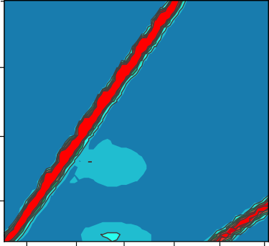

Peak 1

Peak 2

Control

350

350

300

Ex (nm)

300

300

250

250

250

250 300 350 400 450 500

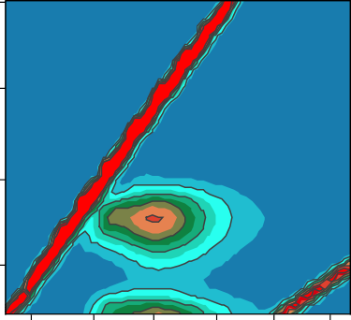

Peak 1

Peak 2

10 mg per g TSS

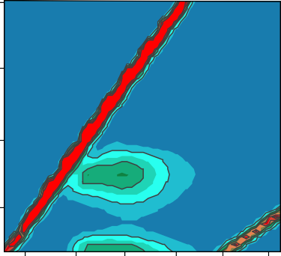

Peak 1

Peak 2

15 mg per g TSS

250 300 350 400 450 500

250 300 350 400 450 500

Ex (nm) Ex (nm) Ex (nm)

**g** 400

**h** 400

**i** 6000

350

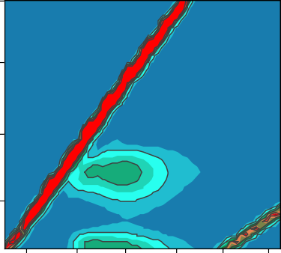

Peak 1

Peak 2

20 mg per g TSS

Ex (nm)

300

250

350

300

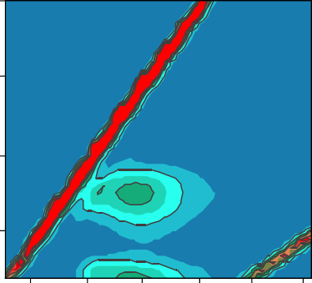

Peak 1

Peak 2

25 mg per g TSS

250

5000

4000

Peak fluorescence intensity (a.u.)

3000

2000

1000

250 300 350 400 450 500

250 300 350 400 450 500

0

Peak 1 Peak 2

Ex (nm) Ex (nm)

Control

10 mg per g TSS

15 mg per g TSS

20 mg per g TSS 25 mg per g TSS

6000

4800

3600

2400

1200 0

1. 90

TB-EPS



**b**

LB-EPS

12

700

9

600

500

6

400

3

300

0

LB-EPS TB-EPS

75 100

−1)

Proteins in LB-EPS (mg COD L−1)

Proteins in TB-EPS (mg COD L−1)

Polysaccharides in LB-EPS(mg COD L

Polysaccharides in TB-EPS (mg COD L−1)

60

80

45

60

30

40

15

0 20

**c** 6000 **d**



TB

LB



3430

1580–1670

1410 1070

TB-25 mg per gTSS

TB-Control

LB-25 mg per gTSS

LB-Control

S-25 mg per gTSS

S-Control

5000

Peak fluorescence intensity (a.u.)

4000

Transmittance (%)

3000

2000

1000



Peak 1

Peak 2

4000 3500 3000 2500 2000 1500 1000 500

Wavenumber (cm−1)

**e f**

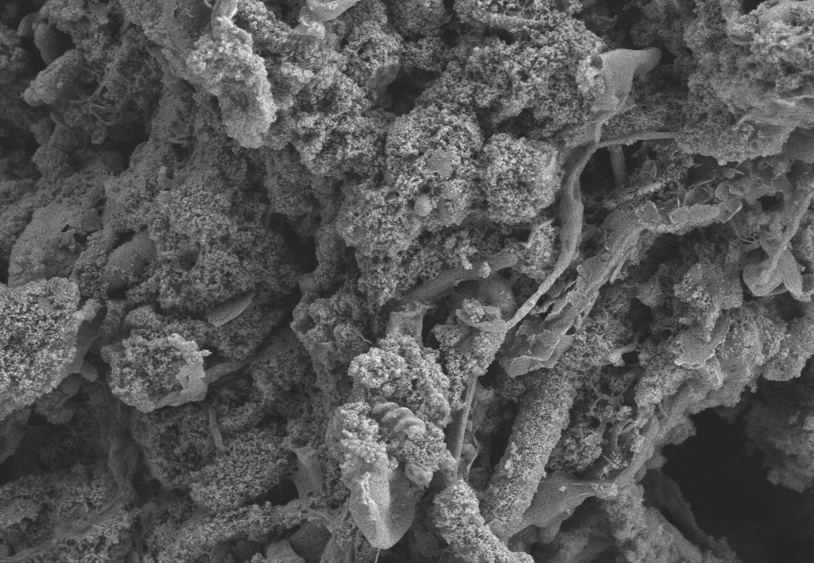

EPS

1 μm

Microbe

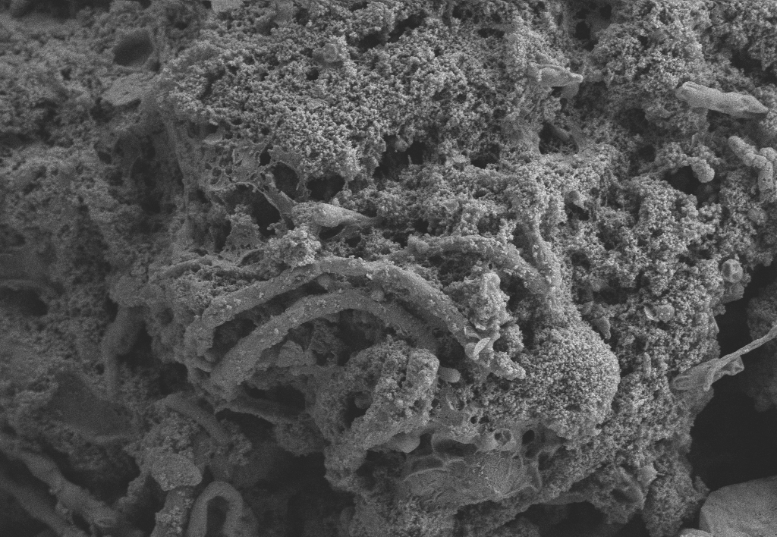

1 μm

**a**

Area% of C1: 40.3%

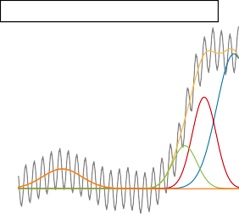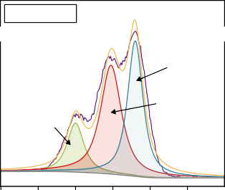

Soluble fraction-25 mg per g TSS

**b**

C 1s-Control

Area% of C2: 43.9% Area% of C3: 15.8%

284.5 eV, C1 C-(C,H)

288.0 eV, C3 C=O,O-C-O

286.1 eV,C2 C-(O,N)

Soluble fraction-Control

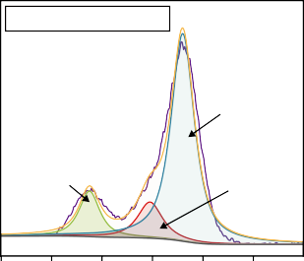

C 1s-25 mg per g TSS

Area% of C1: 72.6% Area% of C2: 13.4% Area% of C4: 14.0%

284.5 eV, C1 C-(C,H)

288.5 eV, C4 O=C-OH,O=C-OR

286.1 eV, C2 C-(O,N)

Absorbance

Intensity (a.u.)

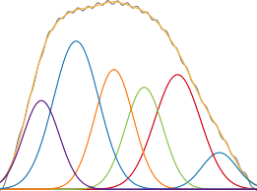

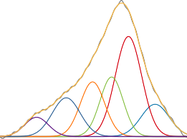1700 1680 1660 1640 1620 1600 1700 1680 1660 1640 1620 1600

LB-25 mg per g TSS

Absorbance

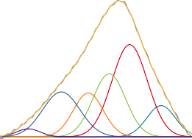

LB-Control

1700 1680 1660 1640 1620 1600 1700 1680 1660 1640 1620 1600

292 290 288 286 284 282

406 404 402 400 398 396 394

Area% of N1: 40.3% Area% of N2: 43.9%

400.4 eV, N2 H-N-C=O

399.6 eV, N1 N-C-R

N 1s-Control

Intensity (a.u.)

292 290 288 286 284 282

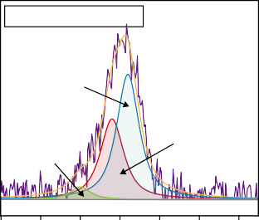

N 1s-25 mg per g TSS

Area% of N1: 57.1% Area% of N2: 37.8%

399.6 eV, N1 Area% of N3: 5.1%

N-C-R

402.0 eV, N2

Inorganic N

400.4 eV, N2 H-N-C=O

406 404 402 400 398 396 394

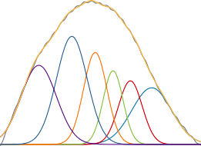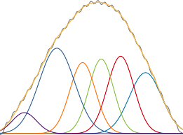

Absorbance

Intensity (a.u.)

TB-Control

TB-25mg per g TSS

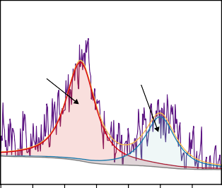

Area% of S1: 34.3% Area% of S2: 65.7%

169.0 eV, S2

Inorganic S

164.0 eV, S1 S-S

S 2p-Control

168.8 eV, S2

Inorganic S

Area% of S1: 19.2% Area% of S2: 80.8%

164.0 eV, S1 S-S

S 2p-25 mg per g TSS

1700 1680 1660 1640 1620 1600

1700 1680 1660 1640 1620 1600

174 172 170 168 166 164 162

174 172 170 168 166 164 162

Wavenumber (cm−1) Wavenumber (cm−1)

**c**

PAA level (mg per g TSS)

Aggregated strands (1610–1625)

5.1

β-sheet

(1630–1640)

Random coil α-Helix (1640-1645) (1648–1657)

3-Turn helix (1659-1672)

Soluble layer

0

21.1

15.4

18.4

27.1

α-helix/ (β-sheet +

random coil)

50.6

LB-EPS

TB-EPS

Samples

Secondary structures (%)

Antiparallel B- sheet/aggregated strands (1680–1695)

12.9

Binding energy (eV)

Binding energy (eV)

|  |  |  |  |  |  |  |  |
| --- | --- | --- | --- | --- | --- | --- | --- |
| 25 | 46.9 | 0 | 0 | 0 | 0 | 11.3 | - |
| 0 | 11.6 | 34.0 | 17.6 | 17.1 | 13.8 | 5.9 | 33.1 |
| 25 | 9.5 | 34.9 | 21.9 | 14.0 | 17.7 | 2.0 | 24.6 |
| 0 | 16.6 | 11.1 | 10.9 | 15.9 | 24.7 | 20.7 | 72.3 |
| 25 | 17.5 | 18.3 | 16.4 | 16.2 | 27.0 | 4.6 | 46.9 |

**a** 18000

12000 14000

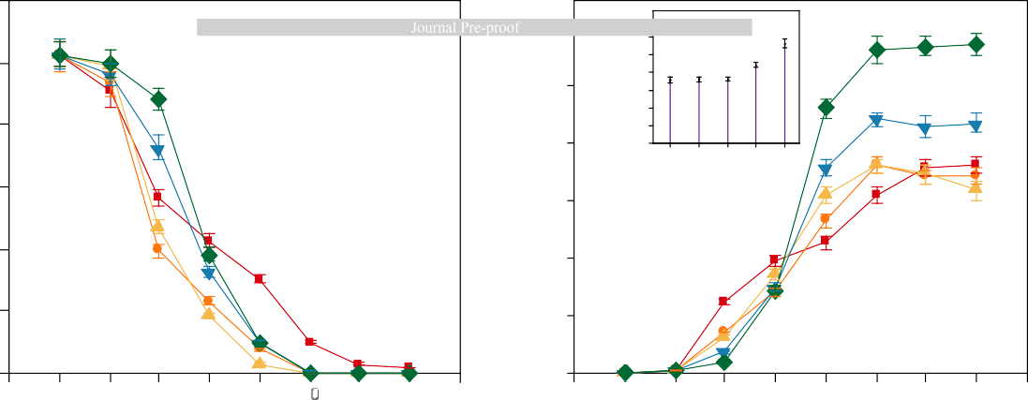

**b**

12000

10000

8000

6000

4000

2000

0

***

**

10000

8000

6000

4000

2000

0

−2

0

2

4

6

8

10 12

14

16

−2

0

2

4

6

8

10 12

14

16

15000

Ethanol concentration (mg COD L−1)

MCFA concentration (mg COD L−1)

Maximal values

12000

9000

6000

3000

0

**c**

5000

4000

LCAs production (mg COD L−1)

3000

2000

1000

0

Time (d)

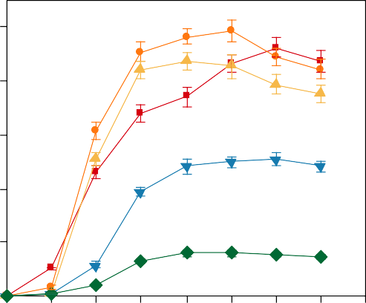**d**

Percentage of products (%)

0 2 4 6 8 10 12 14 16

Time (d)

120

100

80

60

40

20

0

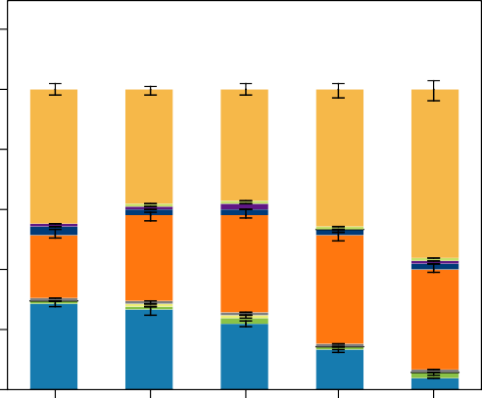Time (d)



Control

n-Caproate

10 mg per g TSS 15 mg per g TSS

20 mg per g TSS

25 mg per g TSS

LCAs

Propionate

n-Butyrate

n-Valerate

iso-Valerate

iso-Caproate

Acetate

iso-Butyrate

**a**



Acidobacteriota

45

36 27 18 9 0

Patescibacteria

Bacteroidota

Chloroflexi

Actinobacteriota

Proteobacteria

Firmicutes

**b** 12.90

Control 15 mg 20 mg 25 mg

10.32

*Candidatus_Microthrix NK4A214_group Acinetobacter Trichococcus*

*Parabacteroides Romboutsia Oscillibacter Paraclostridium*

*Clostridium_sensu_stricto_7*

*Clostridium_sensu_stricto_13 Clostridium_sensu_stricto_1 Clostridium_sensu_stricto_10 Clostridium_sensu_stricto_12*

*Tetrasphaera Denitratisoma Ellin6067*

*Ahniella Methylotenera*

Functional microbe associated with MCFAs production

7.74

Relative abundance (%)

5.16

2.58

Others (e.g., denitrifying bacteria)

0.00

**a b d**

Elevated ORP value

1.8

1.5

1.2

0.9

0.6

0.3

* 1. Control 25 mg per

g TSS

Decreased ORP value

Inducing oxidizing environment

*

* *

* * * * *

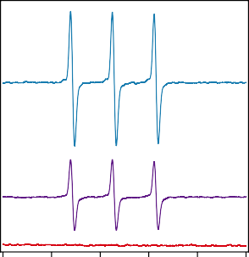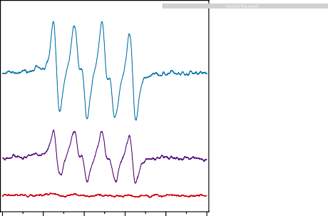

**c**

400

At% of Fe

200

Intensity (a.u.)

ORP (mV)

0

−200

324 326 328 330 332 334 324 326 328 330 332 334 324 326 328 330 332 334

Magnetic field (mT) Magnetic field (mT) Magnetic field (mT)

−400

0 6 12 18 24

Time (h)

5 min 10 min 0 min Control 10 mg per g TSS 15 mg per g TSS 20 mg per g TSS 25 mg per g TSS

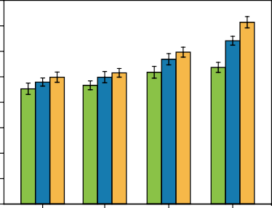**a** 40 **b**

SCFAs production (mg COD L−1)

35

3500

3000

**e**

Cell motility

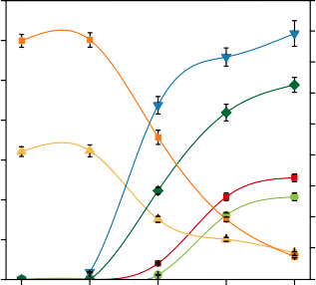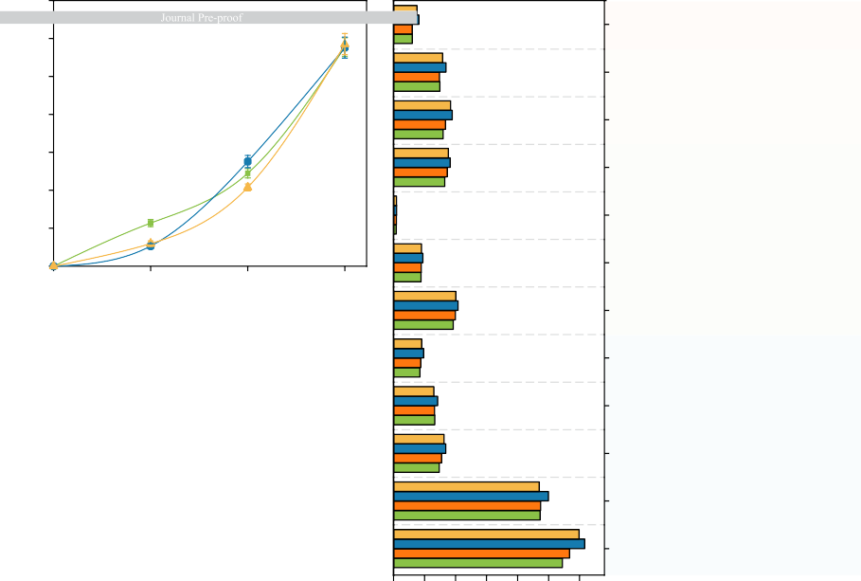

**Cellular processes**

30 2500

BSA degradation (%)

25

2000

20

Signal transduction **Environmental**

**information**

**processing**

Membrane transport

15

10

5

0

1 2 3 4

**c** 7 18

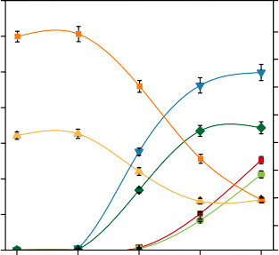

CE: control

1500

1000

500

0

**d** 7

0 1 2 3

18

CE: 25 mg per g TSS

Replication and repair **Genetic**

**processing**

**information**

Transcription

Folding, sorting, and degradation

Translation

6 16 6

Ethanol concentration (mg CODL−1)

14

Acetate & products (×10³ mg COD L−1)

Acetate & products (×10³ mg COD L−1)

5 5

12

4 10 4

3 8 3

2 6 2

4

16 Metabolism of

14 other amino acids

Ethanol concentration (mg CODL−1)

12 Lipid metabolism

10

8 Nucleotide metabolism

6

Amino acid metabolism

4

**Metabolism**

1 2

0 0

0 2 4 6 8

Time (d)

1 2

0 0

0 2 4 6 8

Time (d)

0 1 2 3 4 5 6

Abundance (×106)

Carbohydrate metabolism



Control

15 mg per g TSS

20 mg per g TSS

25 mg per g TSS

Control

Hexanol

20 mg per g TSS

n-Butyrate

25 mg per g TSS

Ethanol

Butanol

Acetate

n-Caproate

**a**

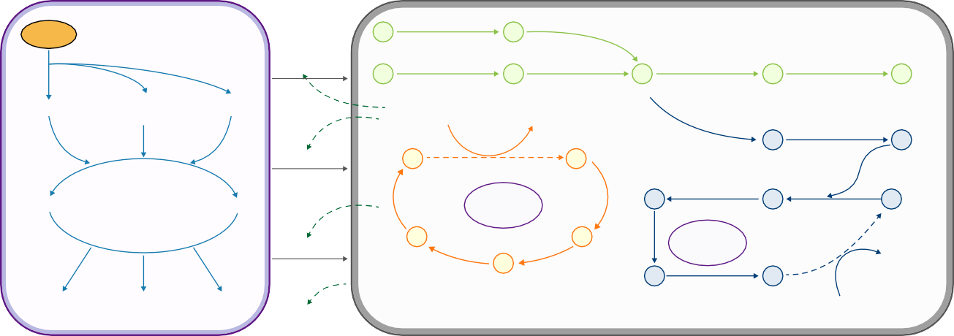

WAS

**Dissolution**

CO2

CO2

1.2.7.4 2.1.1.245

1.1.1.1

CO

1.2.1.3

**Chain elongation**

Polysaccharides

Interme

Proteins

Ethanol Acetaldehyde Acetyl-CoA Acetyl-Pi Acetate

diates

**Hydrolysis**

Acetate

(n)Fatty acid

(n+2)Acyl- CoA

1.3.1.38

(n+2)Fatty acid

(n)Acyl-CoA

6.4.1.2

6.3.4.14

Malonyl-CoA

2.3.1.39

Malonyl-ACP

Amino acids

**Acidification**

Glucose

Next cycle

**RBO**

**pathway**

(n+2)β-

Hydroxyacyl-ACP

2.3.1.16

1.1.1.100

4.2.1.59

(n+2)β-

2.3.1.179

2.3.1.180

(n)Acyl-ACP

Butyrate

(n+2)

Enoyl-CoA

4.2.1.17

(n+2)β-

1.1.1.35

(n+2)β-

Ketoacyl

-CoA

**FAB**

**pathway**

1.3.1.9

Ketoacyl-ACP

(n+2)

Fatty acid

H /CO

Acetate

Other

Hydroxyacyl-CoA

(n+2)

(n+2)

2 2

SCFAs

Caproate

Enoyl-ACP

Acyl-ACP

(n)Fatty acid

1. adh abundance

Abundance

ACACA abundance

fabD abundance

fabH abundance

fabV abundance

0

Control

20000

40000

0 3000 6000 9000 0

30000

60000 0

12000

24000 0

13000

26000 0

13000

26000

15 mg per g TSS

cdhD cdhA

20 mg per g TSS

25 mg per g TSS



**Highlights**

* Peracetic acid (PAA) can boost sludge disruption and provide electron acceptors.
* Medium-chain fatty acids (MCFAs) are promoted to 11,265.6 mg COD L−1 by PAA.
* Free radicals and singlet oxygen are the reactive species for PAA oxidation.
* PAA promotes protein-like substrate hydrolysis and chain elongation.
* PAA induces profitable microbial communities and metabolic pathways.



**Declaration of interests**

☒ The authors declare that they have no known competing financial interests or personal relationships that could have appeared to influence the work reported in this paper.

* The authors declare the following financial interests/personal relationships which may be considered as potential competing interests: